**DRAFT REPORT OF S&T PROJECT**

**on**

**DEVELOPMENT OF GUIDELINES FOR DELINEATION OF WATER STRESSED AREAS AND DESIGNING OF ENVIRONMENTAL FRIENDLY WATER STORAGE STRUCTURE FOR MEETING THE WATER NEEDS IN MINING AREAS**

***Submitted to***

******

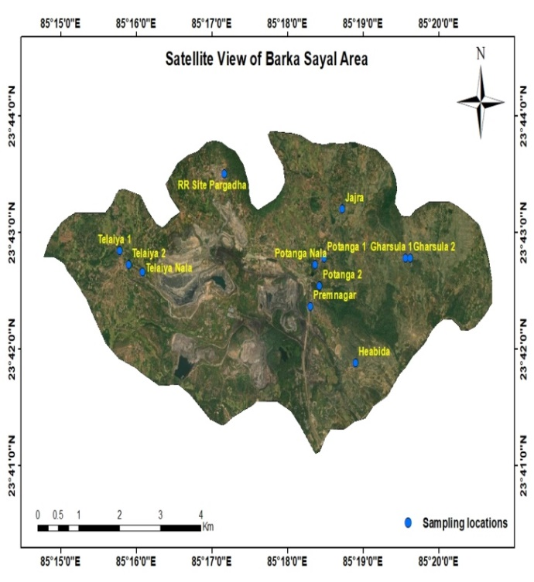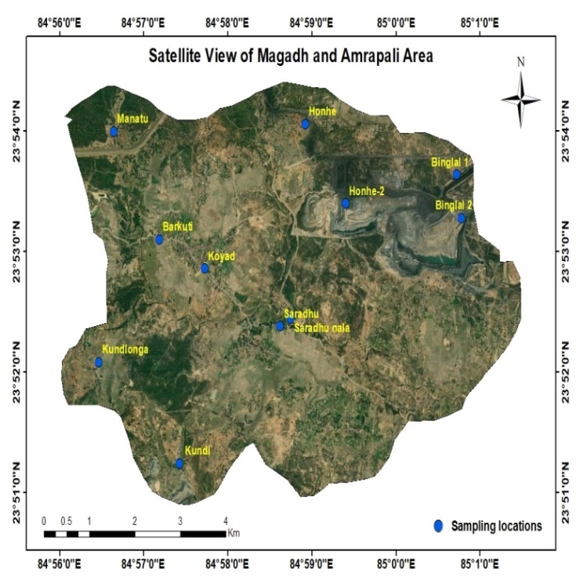

**BARKA SAYAL**

**MAGADH AMRAPALI**

***Submitted By***

**Prof. Prasoon Kumar Singh**

**Department of Environmental Science & Engineering**

**Indian Institute of Technology (Indian School of Mines)**

**Dhanbad – 826 004**

**(Project No.- CIL(20)/2021-2022/845/ESE)**

**April 2023**

**CONTENTS**

|  |  |  |  |  |  |  |
| --- | --- | --- | --- | --- | --- | --- |
| **S. L. No.** |  | | | | | **PAGE NO** |
| **1.0** | **INTRODUCTION** | | | | | **8-14** |
| **1.1** | **General** | | | | **8-13** |
| **1.2** | **Indian scenario** | | | | **8-9** |
| **1.3** | **Rainfall: Major source of water** | | | | **9** |
| **1.4** | **Water scarcity** | | | | **10-11** |
| **1.5** | **Impact of mining on water regime** | | | | **11-12** |
| **2.0** | **STUDY AREA** | | | | | **15-13** |
| **2.1** | **Mapping of study area** | | | | **16-30** |
| **2.1.1** | **Magadh and Amrapali Opencast Mining area** | | | **17-19** |
| **2.1.1.1** | **Topography** | | **19** |
| **2.1.1.2** | **Drainage pattern** | | **20** |
| **2.1.1.3** | **Geomorphology and soil types** | | **20-21** |
| **2.1.1.4** | **Hydrogeology** | | **22-23** |
| **2.1.2** | **Barka Sayal opencast Mining area** | | | **23-24** |
| **2.1.2.1** | **Topography** | | **25-26** |
| **2.1.2.2** | **Climate** | | **27** |
| **2.1.2.3** | **Drainage pattern** | | **27** |
| **2.1.2.4** | **Geomorphology and soil types** | | **27** |
| **2.1.2.5** | **Hydrogeology** | | **28** |
| **2.2** | **Identification of Sampling locations** | | | | **29** |
|  | **2.2.1** | **Sampling locations of Magadh & Amrapali O/c mining area** | | | **29** |
|  | **2.2.2** | **Sampling locations of Barka Sayal O/c mining area** | | | **30** |
| **3.0** | **LABORATORY ANALYSIS AND FIELD WORK** | | | | | **30-41** |
| **3.1** | **Preparation of Base Map** | | | | **31** |
| **3.2** | **Collection of Groundwater Samples** | | | | **31** |
| **3.3** | **Analytical methods** | | | | **32-34** |
| **3.3.1** | **pH** | | | **35** |
| **3.3.2** | **Electrical Conductivity** | | | **36** |
| **3.3.3** | **Turbidity** | | | **36** |
| **3.3.4** | **Total Dissolved Solids (TDS)** | | | **37** |
| **3.3.5** | **Total Hardness** | | | **36-38** |
| **3.3.6** | **Alkalinity** | | | **37-39** |
| **3.3.7** | **Chloride** | | | **39-40** |
| **3.3.8** | **Bicarbonate** | | | **41** |
| **3.3.9** | **Sulfate** | | | **41-42** |
| **4.0** | **SYSTEMATIC MONITORING OF WATER TABLE FLUCTUATIONS** | | | | | **42-50** |
| **4.1** | **Water table fluctuation** | | | | **43** |
| **4.2** | **Water table fluctuation in Barka Sayal O/c mining area** | | | | **44-46** |
| **4.2.1** | **Average Water Level Fluctuation (Pre-monsoon 2022 and Post-monsoon 2022 period)** | | | **49** |
| **4.3** | **Water table fluctuations in Magadh & Amrapali O/c mining area** | | | | **47-49** |
| **4.3.1** | **Average Water Level Fluctuation (Pre-monsoon 2022 and Post-monsoon 2022 period)** | | | **53** |
| **5.0** | **RESULTS AND DISCUSSIONS** | | | | | **51-88** |
| **5.1** | **Water Table fluctuation** | | | | **52** |
| **5.1.1** | **Monitoring of Water Level in Barka Sayal O/c mining area** | | | **55-56** |
| **5.1.2** | **Monitoring of Water Level in Magadh & Amrapali O/c mining area** | | | **56-57** |
| **5.2** | **Qualitative Analysis of water samples** | | | | **54-60** |
| **5.2.1** | **Qualitative Assessment of Chemical parameters of Barka Sayal area (May 2022)** | | | **58** |
|  | **5.2.2** | **Qualitative Assessment of Chemical parameters of Barka Sayal area (Nov 2022)** | | | **59** |
| **5.2.3** | **Qualitative Assessment of Chemical parameters of Barka Sayal area (March 2023)** | | | **60** |
| **5.2.4** | **Qualitative Assessment of Chemical parameters of Magadh Amrapali (May 2022** | | | **58** |
| **5.2.5** | **Qualitative Assessment of Chemical parameters of Magadh & Amrapali (Nov 2022** | | | **61** |
| **5.2.5** | **Qualitative Assessment of Chemical parameters of Magadh & Amrapali (Nov 2022** | | | **62** |
| **5.3** | **Estimation of Hydrogeological Parameter** | | | | **63** |
| **5.3.1** | **Water content of Soil** | | | **64-66** |
| **5.3.2** | **Sieve analysis of Soil** | | | **65** |
| **5.3.2.1** | | **Soil of Barka Sayal O/c mining area** | **66** |
| **5.2.2.2** | | **Soil of Magadh & Amrapali O/c mining area** | **68** |
| **5.3.3** | **Specific gravity of soil** | | | **69** |
| **5.3.3.1** | | **Specific gravity of Barka Sayal O/c mining area** | **69** |
| **5.3.3.2** | | **Specific gravity of Magadh & Amrapali O/c mining area** | **69-70** |
| **5.3.4** | **Dry density** | | | **70** |
| **5.3.4.1** | | **Dry density of Barka Sayal O/c mining area soil** | **71** |
| **5.3.4.2** | | **Dry density of Magadh &Amrapali O/c mining area soil** | **71-72** |
| **5.3.5** | **Void ratio, Porosity and bulk density** | | | **72** |
| **5.3.5.1** | | **Void ratio, Porosity and bulk density of Barka Sayal area soil** | **72** |
| **5.3.5.2** | | **Void ratio, Porosity and bulk density of Magadh & Amrapali area soil** | **72-75** |
| **5.3.6** | **Infiltration rate** | | | **76-82** |
| **5.3.6.1** | | **Infiltration rate of Barka Sayal O/c mining area** | **82-89** |
| **5.3.6.2** | | **Infiltration rate of Magadh &Amrapali O/c mining area** | **82-89** |
| **5.3.7** | **Resistivity Survey Study** | | | **89-90** |
| **6.0** | **IMPORTANT FINDINGS** | | | | | **91-95** |
| **6.1** | **Barka Sayal O/c mining area** | | | | **92-93** |
| **6.2** | **Magadh Amrapali O/c mining area** | | | | **93** |
| **6.3** | **Barka Sayal area infiltration rate** | | | | **94** |
| **6.4** | **Magadh Amrapali area Infiltration rate** | | | | **94-95** |
| **7.0** | **TOTAL EXPENDITURE – FIRST YEAR** | | | | | **96** |
| **7.1** | **FIRST-YEAR EXPENDITURE** | | | | **97** |
| **7.2** | **Total Cost of the Project and Funds received (March 2022) - FIRST YEAR from CIL** | | | | **97** |
| **7.3** | **FORM - II** | | | | **98** |
| **7.4** | **FORM - III** | | | | **99** |
| **7.5** | **FORM - IV** | | | | **100** |
| **8.0** | **REQUIREMENTS FOR THE 3RD - YEAR** | | | | | **101** |

**LIST OF TABLES**

|  |  |  |
| --- | --- | --- |
| **Table No.** | **Description of Tables** | **Page No.** |
| **Table 2.1** | **Number of sampling locations** | **33** |
| **Table 2.2** | **Sampling location of Magadh and Amrapali area with latitude and longitude** | **33** |
| **Table 2.3** | **Sampling location of Barka Sayal area with latitude and longitude** | **34** |
| **Table 3.1** | **Physicochemical with there testing instrument** | **38** |
| **Table 3.2** | **Ions causing Hardness** | **42** |
| **Table 4.1** | **Locations details and sources of water samples from Barka Sayal area** | **51** |
| **Table 4.2** | **Monitoring of water level (mbgl) in May, 2022** | **51** |
| **Table 4.3** | **Monitoring of water level (mbgl) in June,2022** | **52** |
| **Table 4.4** | **Monitoring of water level (mbgl) in November,2022** | **52** |
| **Table 4.5** | **Monitoring of water level (mbgl) in January, 2023** | **53** |
| **Table 4.6** | **Water level fluctuation of Barka Sayal Area** | **54** |
| **Table 4.7** | **Locations details and Source where water collected of Magadh & Amrapali Area** | **55** |
| **Table 4.8** | **Monitoring of water level (mbgl) in May, 2022** | **56** |
| **Table 4.9** | **Monitoring of water level (mbgl) in June, 2022** | **56** |
| **Table 4.10** | **Monitoring of water level (mbgl) in November, 2022** | **57** |
| **Table 4.11** | **Monitoring of water level (mbgl) in January, 2023** | **57** |
| **Table 4.12** | **Water level fluctuation of Magadh & Amrapali Area** | **58** |
| **Table 5.1** | **Locations details and chemical water quality test result of Barka Sayal area in May 2022** | **63** |
| **Table 5.2** | **Locations details and chemical water quality test result of Barka Sayal area in Nov 2022** | **64** |
| **Table 5.3** | **Locations details and chemical water quality test result of Magadh & Amrapali area in May 2022** | **65** |
| **Table 5.4** | **Locations details and chemical water quality test result of Magadh & Amrapali area in Nov 2022** | **66** |
| **Table 5.5** | **Sieving data of Barka Sayal Area of different sieve size** | **71** |
| **Table 5.6** | **Sieving data of Magadh Amrapali Area of different sieve size** | **72** |
| **Table 5.7** | **Specific gravity of Barka Sayal Area** | **76** |
| **Table 5.8** | **Specific gravity of Magadh Amrapali Area** | **76** |
| **Table 5.9** | **Dry density of Barka Sayal Area** | **77** |
| **Table 5.10** | **Dry density of Magadh Amrapali Area** | **78** |
| **Table 5.11** | **Void ratio, Porosity and Buk density of Barka Sayal Area** | **80** |
| **Table 5.12** | **Void ratio, Porosity and Buk density of Magadh Amrapali Area** | **80** |
| **Table 5.13** | **Infiltration rate of Tilaiya Village** | **85** |
| **Table 5.14** | **Infiltration rate of Heabida Village** | **86** |
| **Table 5.15** | **Infiltration rate of Garsula Village** | **87** |
| **Table 5.16** | **Infiltration rate of R.R Site, Pargarha Village** | **88** |
| **Table 5.17** | **Infiltration rate of Potanga Village** | **89** |
| **Table 5.18** | **Infiltration rate of Jarjara Village** | **90** |
| **Table 5.19** | **Infiltration rate of Koed Village** | **91** |
| **Table 5.20** | **Infiltration rate of Binglat Village** | **92** |
| **Table 5.21** | **Infiltration rate of Barkuti Village** | **93** |
| **Table 5.22** | **Infiltration rate of Saradhu Village** | **94** |
| **Table 5.23** | **Infiltration rate of R.R Site, Honhe Village** | **95** |
| **Table 5.24** | **Infiltration rate of Kurlonga Village** | **96** |
| **Table 5.25** | **Infiltration rate of Kundi Village** | **97** |
| **Table 6.1** | **Showing water Parameter more than permissible limit of Barka Sayal Area** | **101** |
| **Table 6.2** | **Showing water Parameter more than permissible limit of Magadh and Amrapali Area** | **102** |

**LIST OF FIGURES**

|  |  |  |
| --- | --- | --- |
| **Figure No.** | **Description of Figures** | **Page No.** |
| **Fig 2.1** | **Sampling Locations of Study area** | **19** |
| **Fig 2.2** | **Satellite map of Magadh & Amrapali Mining Area** | **20** |
| **Fig 2.3** | **Elevation map of Magadh & Amrapali mining Area** | **23** |
| **Fig 2.4** | **Drainage Map of Magadh & Amrapali mining Area** | **23** |
| **Fig 2.5** | **Lithological map of Magadh & Amrapali Area** | **25** |
| **Fig 2.6** | **Map shows satellite view of Barka Sayal Area** | **28** |
| **Fig 2.7** | **Elevation map of Barka Sayal Area** | **30** |
| **Fig 2.8** | **Drainage Map of Barka Sayal mining Area** | **31** |
| **Fig 2.9** | **Lithological map of Barka Sayal Area** | **32** |
| **Fig 4.1** | **Flow chart of adopted research work** | **49** |
| **Fig 5.1** | **Bar chart showing water level fluctuation of Pre and Post Monsoon season of Barka Sayal area** | **60** |
| **Fig 5.2** | **Showing water level fluctuation of Pre and Post Monsoon season of Barka area** | **61** |
| **Fig 5.3** | **Bar chart showing water level fluctuation of Pre and Post Monsoon season of Barka Sayal area** | **61** |
| **Fig 5.4** | **Showing water level fluctuation of Pre and Post Monsoon season of Barka Sayal area** | **62** |
| **Fig 5.5** | **Infiltration rate graph of Tilaiya Village** | **86** |
| **Fig 5.6** | **Infiltration rate of Heabida Village** | **87** |
| **Fig 5.7** | **Infiltration rate graph of Garsula Village** | **88** |
| **Fig 5.8** | **Infiltration rate graph of R.R Site Pargarha Village** | **89** |
| **Fig 5.9** | **Infiltration rate graph of Potanga Village** | **90** |
| **Fig 5.10** | **Infiltration rate graph of Jarjara Village** | **91** |
| **Fig 5.11** | **Infiltration rate graph of Koed Village** | **92** |
| **Fig 5.12** | **Infiltration rate graph of Binglat Village** | **93** |
| **Fig 5.13** | **Infiltration rate graph of Barkuti Village** | **94** |
| **Fig 5.14** | **Infiltration rate graph of Saradhu Village** | **95** |
| **Fig 5.15** | **Infiltration rate of R.R Site, Honhe Village** | **96** |
| **Fig 5.16** | **Infiltration rate graph of Kurlonga Village** | **97** |
| **Fig 5.17** | **Infiltration rate graph of Kundi Village** | **98** |
| **Fig 7.1** | **First Year Expenditure** | **106** |
| **Fig 7.2** | **Total cost of the Project and fund received (March 2022)** | **106** |
| **Fig 7.3** | **Form-ii** | **107** |
| **Fig 7.4** | **Form- iii** | **108** |
| **Fig 7.5** | **Form-iv** | **109** |

**CHAPTER 1**

***Introduction***

****

**1**

**INTRODUCTION**

**1.1 General**

#### Water scarcity refers to the situation where the demand for water exceeds the available supply of water, either temporarily or permanently. It is a global challenge that affects many regions around the world and has become a critical issue in many places. Water scarcity can be caused by various factors, including overuse, pollution, climate change, and inadequate water management practices.

#### Water is essential for human survival, as well as for agriculture, industry, and other economic activities. However, as the global population continues to grow, the demand for water is increasing, and water resources are becoming increasingly scarce. The effects of water scarcity can be severe, including waterborne diseases, reduced crop yields, economic losses, and even social unrest.

#### Addressing water scarcity requires a comprehensive approach that involves improving water management practices, reducing waste, conserving water resources, and promoting sustainable water use. It also requires international cooperation and a commitment to addressing the underlying causes of water scarcity, such as climate change and environmental degradation.

Water stress in mining areas occurs when the demand for water exceeds the available supply. This can be caused by the large amount of water used in mining processes, as well as the impact of mining activities on local water sources. To address this issue, water storage structures can be established in suitable locations. Ideal locations for water storage structures include areas with high precipitation, access to a nearby water source, and low potential for flooding. The location should also be close to the mining site to reduce the cost and energy required for transportation. Additionally, the location should be protected from damage or contamination to ensure the long-term sustainability of the water supply.

Water stress in mining areas refers to the situation when there is insufficient water available to meet the demands of the various human and ecological activities in the area. This can occur due to various factors such as over-extraction of groundwater, increased demand due to population growth and industrial activities, and degradation of water resources due to pollution from mining activities.

In order to mitigate water stress in mining areas, it is important to establish environmental friendly water storage structures. A suitable place for this would be near a source of water, such as a river or lake, so that the stored water can be easily transported to the mining site. The location should also have a stable geology, so that the structure is able to withstand any potential earthquakes or other geological events.

In addition, it is important to choose a location that has a low risk of flooding, and is not prone to drought conditions. The area should also be easily accessible, so that maintenance and management of the structure can be easily carried out.

It is also important to consider the potential impact of the water storage structure on the surrounding ecosystem. The structure should be designed in a way that minimizes its impact on the environment, for example by using permeable materials for the walls and floor, and by ensuring that there is adequate treatment of any waste water generated.

In summary, a suitable location for an environmental friendly water storage structure in a mining area would be near a source of water, have a stable geology, be easily accessible, have low risk of flooding and drought, and minimize its impact on the surrounding ecosystem.

#### 1.2 Indian Scenario:

#### India faces significant challenges when it comes to water scarcity, which is driven by several factors including population growth, climate change, inefficient water management practices, and the overexploitation of groundwater resources.

#### 

#### According to the NITI Aayog, a government think tank in India, around 600 million people, or almost half of India's population, face high to extreme water stress. This is primarily due to over-extraction of groundwater, which is the primary source of water for agriculture, domestic and industrial use. In fact, India is the largest user of groundwater in the world, and water tables are declining at an alarming rate in many parts of the country.

#### 

#### In addition, surface water sources, such as rivers and lakes, are also under severe stress due to pollution, overuse, and climate change. The country's per capita water availability has also been declining rapidly over the past few decades, making it one of the most water-stressed countries in the world. Water scarcity in India has a significant impact on the country's economy, environment, and social fabric. It has severe implications for agriculture, which employs a significant proportion of the country's workforce and contributes to a major share of the GDP. Water scarcity also exacerbates social inequalities, particularly affecting the poor, women, and marginalized communities, who often have limited access to safe.

#### 1.3 Rainfall is the major source of water

#### India is one of the most populous countries in the world, with a population of over 1.3 billion people as of 2021. Despite having a significant land area, India faces severe water scarcity due to its rapidly growing population and uneven distribution of water resources. Here are some statistics and data on Indian water scarcity:

#### Total water resources: According to the Central Water Commission, India has a total water resource potential of 1,123 billion cubic meters (BCM) per year, which includes the annual precipitation, river flows, and groundwater recharge. However, due to various factors, including poor management and distribution, only 690 BCM of this potential is utilizable.

#### Per capita availability: The per capita availability of water in India is decreasing rapidly due to population growth and urbanization. As of 2021, the per capita availability of water is estimated to be around 1,460 cubic meters per year, which is well below the minimum requirement of 1,700 cubic meters per year.

#### Water scarcity: According to the National Institute for Transforming India (NITI Aayog), around 600 million people in India face high to extreme water stress, which means that they have limited access to water for daily use. The report also states that by 2030, India's water demand is projected to be twice the available supply, which could lead to severe water scarcity.

#### Groundwater depletion: India is the largest user of groundwater in the world, with over 60% of irrigated agriculture relying on groundwater. However, due to overexploitation and lack of regulation, groundwater levels are rapidly declining in many parts of the country. According to a study by NASA, India has lost 109 cubic kilometers of groundwater between 2002 and 2008.

#### Water quality: In addition to scarcity, India also faces water quality issues, with many water sources contaminated by industrial and agricultural pollutants. According to the Water Aid report, 21% of communicable diseases in India are related to unsafe water, sanitation, and hygiene.

#### Overall, India's water scarcity is a significant challenge that requires immediate action and long-term planning to ensure sustainable use and management of water resources.

#### Here are some more specific data points on Indian water scarcity:

#### Droughts: According to the Indian government, between 2015 and 2019, over 500 million people were affected by droughts in India. In 2019 alone, over 150 districts in India were declared as drought-hit.

#### Water stress: According to the World Resources Institute, 54% of India's total area is experiencing high to extremely high water stress, which means that the demand for water is significantly higher than the available supply. This puts India in the "extremely high" category of water stress, along with countries like Qatar and Israel.

#### Urban water scarcity: India's rapidly growing urban population is exacerbating water scarcity in cities. According to the NITI Aayog, 21 major Indian cities, including Delhi, Bengaluru, and Chennai, are expected to run out of groundwater by 2020. The situation is particularly severe in Chennai, where residents have been facing acute water shortages in recent years.

#### Agriculture: Agriculture is the largest user of water in India, accounting for around 90% of total water usage. However, due to inefficient irrigation practices, much of this water is wasted, and farmers are facing increasing water scarcity. According to the NITI Aayog, the water-use efficiency of Indian agriculture is only 38%, compared to 60-80% in developed countries.

#### Groundwater depletion: As I mentioned earlier, groundwater depletion is a significant issue in India. According to a study published in Nature, groundwater levels are declining by an average of 0.3 meters per year in northwest India, which is one of the most productive agricultural regions in the country.

#### Overall, these data points illustrate the severity of water scarcity in India, which is a significant challenge that requires urgent action and investment in sustainable water management practices.

#### 1.4 Water Scarcity

#### Jharkhand is a mineral-rich state in eastern India, and mining is a significant contributor to its economy. However, mining activities in Jharkhand have also led to severe water scarcity issues, particularly in areas where open-cast mining is practiced. Here are some specific points regarding water scarcity in Jharkhand's mining areas:

#### Surface water contamination: Mining activities in Jharkhand often involve the use of chemicals and other pollutants that can contaminate surface water sources, such as rivers and streams. This can make it difficult or impossible for local communities to use these water sources for drinking, bathing, and other daily needs.

#### Groundwater depletion: Open-cast mining involves removing large amounts of soil and rock, which can impact the local groundwater table. As a result, groundwater levels can decline, and nearby wells and boreholes may run dry, leading to water scarcity for local communities.

#### Water-intensive mining operations: Mining operations in Jharkhand can be highly water-intensive, requiring large amounts of water for processing, dust suppression, and other purposes. This can put additional pressure on local water resources and exacerbate water scarcity issues.

#### Limited access to clean water: In many mining areas of Jharkhand, access to clean water is limited, with local communities forced to rely on contaminated or unreliable water sources. This can lead to a range of health issues, including water-borne diseases and malnutrition.

#### Overall, the combination of surface water contamination, groundwater depletion, and water-intensive mining operations has led to severe water scarcity issues in Jharkhand's mining areas. This underscores the need for sustainable mining practices that take into account the impacts of mining activities on local water resources and the communities that depend on them.

#### 1.5 Impact of Mining on Water Regime

#### Mining activities can have a significant impact on water regimes in the surrounding environment. The impact can be both positive and negative, depending on the type of mining operation, the location, and the methods used. Some of the impacts of mining on water regimes include:

#### Water Pollution: Mining activities can release a variety of pollutants, such as heavy metals, chemicals, and acid mine drainage (AMD) into water sources. This can lead to the contamination of drinking water sources, harm aquatic life and disrupt ecosystem health.

#### Water Depletion: Mining activities require a significant amount of water, which can deplete local water sources, particularly in arid and semi-arid regions. This can cause a water shortage for local communities and ecosystems, leading to increased competition for scarce water resources.

#### Alteration of watercourses and hydrology: Mining activities can change the flow and direction of rivers and streams, which can affect the hydrology of the surrounding environment. This can result in the loss of wetlands, erosion, and sedimentation of water bodies.

#### Soil erosion: Mining can remove vegetation and soil cover, leading to soil erosion, which can impact water quality and quantity. The eroded sediments can clog waterways, and degrade water quality by carrying pollutants and nutrients into water bodies.

#### Groundwater contamination: Mining activities can impact groundwater quality, particularly if mining operations occur below the water table. Heavy metals and other contaminants released through mining activities can seep into the groundwater, making it unusable for drinking or agricultural purposes.

#### 

#### In summary, mining activities can have significant impacts on water regimes, causing water pollution, water depletion, alteration of watercourses and hydrology, soil erosion, and groundwater contamination. It is important for mining companies to develop and implement responsible mining practices that minimize these impacts and protect the environment and the communities that depend on it.

#### Open-cast mining, also known as surface mining, involves the extraction of minerals or resources from the earth's surface, often by digging or blasting away large areas of land. This type of mining can have significant impacts on water scarcity, which occurs when there is not enough water to meet the demands of people and the environment.

#### 

#### Here are some of the potential impacts of opencast mining on water scarcity:

#### Water depletion: Opencast mining can use large amounts of water for dust suppression, washing of minerals, and other processes. This can deplete local water resources, especially in areas that are already experiencing water scarcity.

#### Contamination of water sources: Mining activities can pollute nearby streams, rivers, and groundwater sources with toxic chemicals, heavy metals, and other pollutants. This can make the water unusable for drinking, irrigation, or other purposes.

#### Alteration of hydrology: Opencast mining can alter the natural flow of water in a landscape, leading to changes in the availability and quality of water resources downstream. This can have significant impacts on local ecosystems and the people who rely on those ecosystems for their livelihoods.

#### Competition for water: Opencast mining can compete with other water users, such as farmers, households, and other industries, for limited water resources. This can exacerbate existing water scarcity and lead to conflicts over water access and use.

#### Surface water depletion: Open-cast mining requires the removal of large quantities of rock, soil, and vegetation, which can disrupt the natural hydrological cycle and cause surface water depletion. This can result in reduced water availability for nearby communities, agriculture, and other uses.

#### Groundwater depletion: The removal of large quantities of rock and soil can also lead to groundwater depletion, as it can reduce the natural ability of the soil and rocks to retain water. This can affect the water supply for nearby communities, as well as the availability of water for local ecosystems.

#### Water pollution: Open-cast mining can also result in the contamination of nearby water sources due to the release of heavy metals, chemicals, and other pollutants from mining activities. This can make the water unsafe for human consumption, irrigation, and other uses.

#### Changes in water quality: Mining activities can also alter the quality of nearby water sources, making the water unsuitable for certain uses. For example, mining activities can cause an increase in the concentration of dissolved solids, which can make the water unsuitable for irrigation or other agricultural uses.

#### Overall, opencast mining can have significant impacts on water scarcity, which can in turn affect local ecosystems, human health, and the economy. It is important for mining companies to take steps to minimize these impacts through responsible water management practices and by engaging with local communities and stakeholders to understand and address their water needs and concerns.

**CHAPTER 2**

***Study Area***

****

**2**

**STUDY AREA**

**2.1. MAPPING OF STUDY AREA**

Magadh and Amrapali coal mine are located in Chatra district in the Indian state of Jharkhand. These mines are operated by Central Coalfields Limited (CCL), a subsidiary of Coal India Limited, the largest coal-producing company in the world.

The Barka-Sayal-Ramgarh district is located in the Indian state of Jharkhand and is known for its abundant coal reserves. The district is home to several coal mines that are operated by Coal India Limited, the largest coal-producing company.

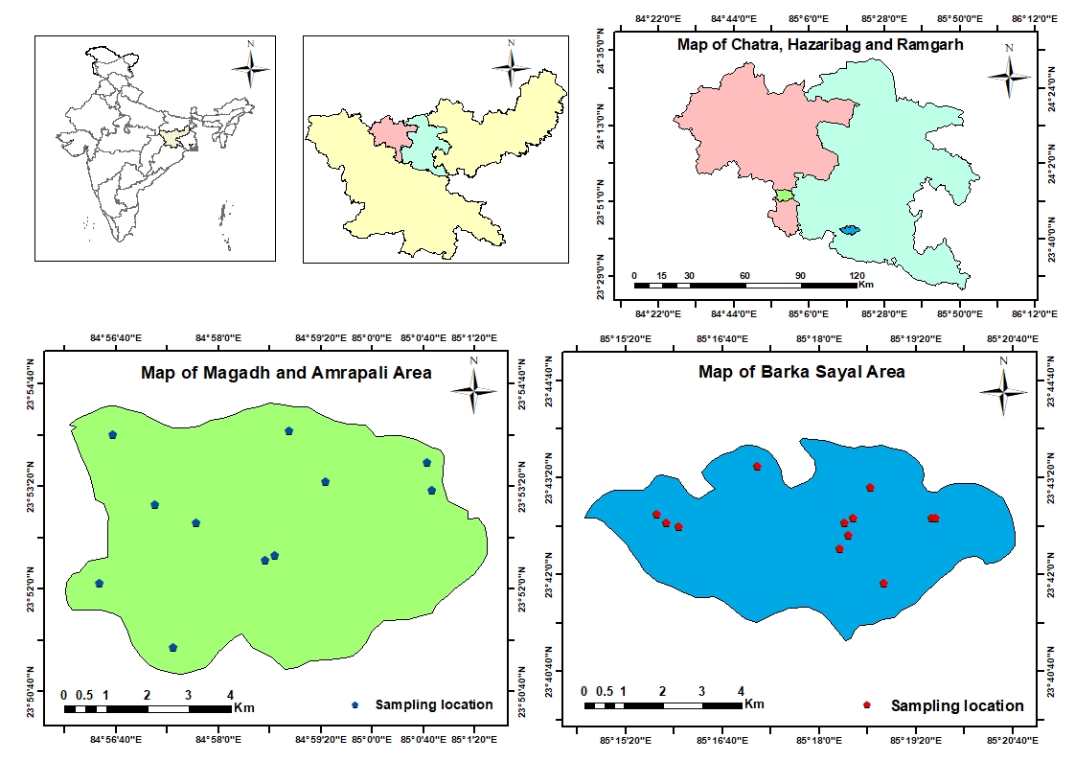

**BARKA SAYAL AREA**

**MAGADH AMRAPALI AREA**

**Fig2.1 Sampling Locations of Study area**

**2.1.1 Magadh & Amrapali Mining Area:**

Magadh and Amrapali area is one of the most important Coal mining area in India, located in Chatra District, Jharkhand in Survey of India Toposheet No. 73A/13 lies between Latitude: 23o40’1” N to 23o58’2.25” N Longitude: 84o26’50” E to 85o10’0.56” E. Magadh and Amrapali coal mines are located in Chatra district in the Indian state of Jharkhand. These mines are operated by Central Coalfields Limited (CCL), a subsidiary of Coal India Limited, the largest coal-producing company in the world.

The Magadh and Amrapali coal mines are part of the North Karanpura coalfield, which is one of the largest coal reserves in India. The coalfield spans over an area of about 444 square kilometers and contains high-quality coal with low ash and sulfur content.

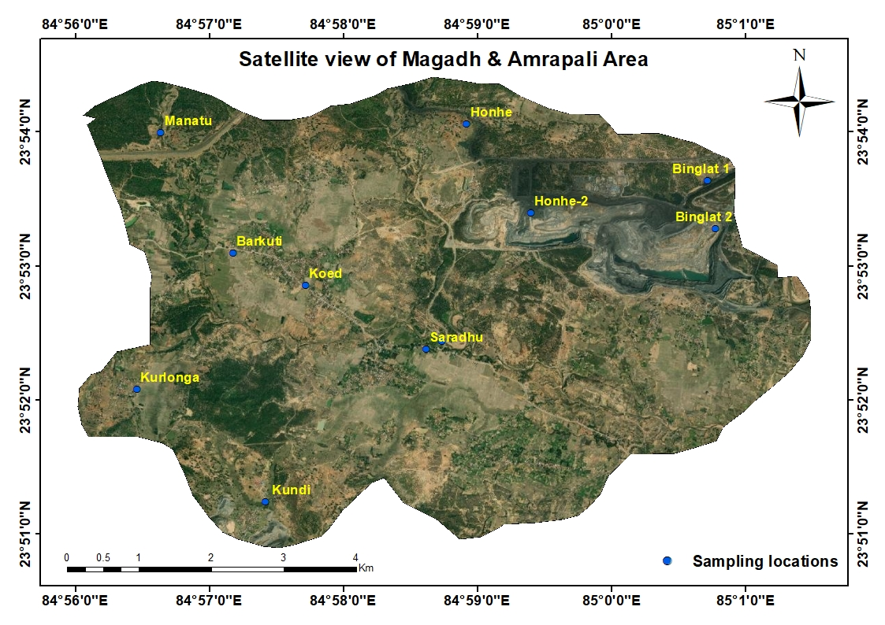 Mining in the Magadh and Amrapali areas involves open-pit mining methods. The extracted coal is primarily used for power generation, and a large portion of it is supplied to the national grid to meet the growing energy demand in India. However, the impact of mining on the environment and local communities in the Chatra district has been a cause for concern. The extraction and processing of coal can result in the release of pollutants into the air and water, leading to environmental degradation and potential health hazards for nearby residents. It is important to note that the government and the coal-producing companies have a responsibility to minimize the negative impact of mining on the environment and local communities. This can include implementing effective waste management practices, restoring damaged ecosystems, and providing compensation to affected communities.

**Fig2.2 Satellite map of Magadh & Amrapali Mining area**

Magadh Area is one of the operational areas of the [Central Coalfields Limited](https://en.wikipedia.org/wiki/Central_Coalfields) located in the [Tandwa](https://en.wikipedia.org/wiki/Tandwa_block) [CD block](https://en.wikipedia.org/wiki/Community_development_blocks_in_India) in the [Chatra](https://en.wikipedia.org/wiki/Chatra_district) district in the state of [Jharkhand](https://en.wikipedia.org/wiki/Jharkhand), India.

[North Karanpura Coalfield](https://en.wikipedia.org/wiki/North_Karanpura_Coalfield) has reserves of 14 billion tonnes of coal (proved, indicated and inferred), around 9% of India's total coal reserves, placing it among the biggest [coalfields](https://en.wikipedia.org/wiki/List_of_coalfields) in India. Only a small corner of this coalfield was exploited earlier.

Future mega projects in the area include: Magadh opencast project expansion with nominal capacity of 51 million tonnes per year and peak capacity of 70 million tonnes per year, Amrapali OCP expansion with nominal capacity 25 MTY and peak capacity of 35 MTY, Sanghamitra OCP with nominal capacity of 20 MTY and peak capacity of 27 MTY, and Chandragupta OCP with nominal capacity of 15 MTY and peak capacity of 20 MTY.

Magadh Opencast Project was identified for a rated capacity of 12.0 million tonnes per year for supplying coal to the [North Karanpura Thermal Power Station](https://en.wikipedia.org/wiki/North_Karanpura_Thermal_Power_Station) (3X660 MW) of [NTPC Limited](https://en.wikipedia.org/wiki/NTPC_Limited) at [Tandwa](https://en.wikipedia.org/wiki/Tandwa). Estimated mineable reserve of Magadh OCP was 351 million tonnes. It is operating in 4 coal blocks: Magadh, Tandwa, Dumargarh and Karimati. The area has flat terrain with gentle undulation. The maximum elevation is 509 metres (1,670 ft) in the northern side of the block. The minimum elevation is 464 metres (1,522 ft) near the southern block boundary. It started operations in 2015. It is linked with Tandwa by a 12 km long fair-weather kutcha (unpaved) road. In July 2020, Central Coalfields Limited invited bids for development and operationalisation of Sanghamitra OCP. Duration of the contract is 25 years.

**Amrapali Area** is another one of the operational areas of the [Central Coalfields Limited](https://en.wikipedia.org/wiki/Central_Coalfields) located in the [Tandwa](https://en.wikipedia.org/wiki/Tandwa_block) [CD block](https://en.wikipedia.org/wiki/Community_development_blocks_in_India) of the [Chatra](https://en.wikipedia.org/wiki/Chatra_district) district in the state of [Jharkhand](https://en.wikipedia.org/wiki/Jharkhand), India. [North Karanpura Coalfield](https://en.wikipedia.org/wiki/North_Karanpura_Coalfield) has reserves of 14 billion tonnes of coal (proved, indicated and inferred), around 9% of India's total coal reserves, placing it among the biggest [coalfields](https://en.wikipedia.org/wiki/List_of_coalfields) in India. Only a small corner of this coalfield was exploited earlier.

Future mega projects in the area include: Magadh opencast project expansion with nominal capacity of 51 million tonnes per year and peak capacity of 70 million tonnes per year, Amrapali OCP expansion with nominal capacity 25 MTY and peak capacity of 35 MTY, Sanghamitra OCP with nominal capacity of 20 MTY and peak capacity of 27 MTY, and Chandragupta OCP with nominal capacity of 15 MTY and peak capacity of 20 MTY

Amrapali open cast project in the [North Karanpura Coalfield](https://en.wikipedia.org/wiki/North_Karanpura_Coalfield) is located in the Chatra district and supplies coal to [Barh Super Thermal Power Station](https://en.wikipedia.org/wiki/Barh_Super_Thermal_Power_Station" \o "Barh Super Thermal Power Station). It has an annual rated capacity of 12 million tonnes per year. With a mineable reserve of 124.79 million tonnes, it has a life of 11 years, as on 31 March 2018. It operates in two geological blocks: Amrapali and Krishnapur. An 80 km metalled road connecting Tandwa with Hazaribagh, via Simaria passes through the area.[[5]](https://en.wikipedia.org/wiki/Amrapali_%26_Chandragupta_Area#cite_note-5)

As of 2020, as per a newspaper report, Central Coalfields Limited has initiated steps for acquisition of 3331.50 acres of land in 7 villages (6 in [Keredari](https://en.wikipedia.org/wiki/Keredari_(community_development_block)" \o "Keredari (community development block)) CD block in Hazaribagh district and 1 in [Tandwa](https://en.wikipedia.org/wiki/Tandwa_block) CD block in Chatra district) for the Chandragupta open cast project. The announcement is being made in the villages with the beating of drums. Quoting company officials, the report says that the area has reserves of 600 million tonnes of coal, and annual production target is 20 million tonnes.

**2.1.1.1 Topography of Magadh and Amrapali Area:**

Magadh and Amrapali mining areas are located in the state of Jharkhand in India, which is a region characterized by a rugged topography. The area is situated in the eastern part of India, and it is rich in mineral resources such as coal, iron ore, and copper.

The topography of the Magadh and Amrapali mining areas is mainly hilly with several plateaus, valleys, and ridges. The region is surrounded by several mountains such as the Rajmahal hills, which are the eastern extension of the Vindhya Range. These hills form the northern and western boundaries of the mining areas.

The region is drained by several rivers such as the Damodar, Barakar, and Ajay rivers. These rivers flow from the north to the south and are tributaries of the Ganges River. The Damodar River is the most important river in the region, and it has several tributaries that originate from the hills. The hills in the region are composed of various rock formations such as granite, gneiss, and schist. These rocks are rich in minerals such as iron, coal, and copper. The mining activities in the region are mostly focused on the extraction of coal, which is found in abundance in the region.

In summary, the topography of the Magadh and Amrapali mining areas is characterized by hilly terrain with several plateaus, valleys, and ridges. The region is drained by several rivers, and the hills are rich in minerals such as coal, iron, and copper.

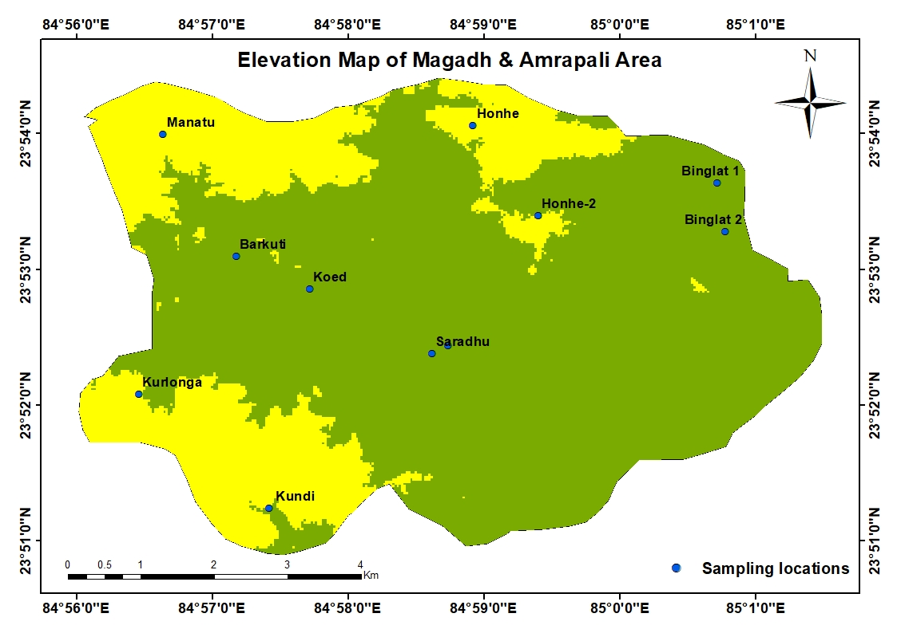

**Fig 2.3 Elevation map of Magadh & Amrapali mining Area**

**2.1.1.2 Drainage pattern**

### The principal rivers of the district are Yamuna, Barki, Chako, Damodar and Garhi.The general slope of the district is North to South. The general trend of the drainage is from SE-NW.

### 

### **Fig 2.4 Drainage Map of Magadh & Amrapali mining Area**

### **2.1.1.3 Geomorphology and Soil types**

The predominant physical feature over major part of the district is the rolling topography dotted with isolated inselbergs except in the Borijore and Sundarpahari blocks. A substantial part of Borijore and Sundarpahari block is under forest cover. The altitude of the land surface increases from west to the east. The major hills are confined to the eastern part of the district comprising the Gandeshwari Pahar (238.41m) and Kesgari Pahar (268.29m) while in the western part of the district isolated hills are in the form of the inselbergs and other small hillocks.

The soil is mostly acidic, reddish yellow, light textured and highly permeable with poor water holding capacity. The region is characterized by its hilly topography and narrow valleys, which are primarily formed by the erosion of the surrounding mountains.

The area is located within the Chota Nagpur Plateau, which is a large plateau in eastern India that is composed of several smaller plateaus and hills. The region is rich in mineral resources, including coal, iron, and bauxite, which has led to extensive mining activity in the area.

The topography of the region is dominated by hills and ridges that are generally oriented in a north-south direction. The hills and ridges are composed of hard rocks, such as granite, gneiss, and quartzite, that are resistant to weathering and erosion. The valleys, on the other hand, are composed of softer rocks, such as shale and sandstone that are easily eroded.

The rivers in the region, including the Damodar and the Barakar, have played a significant role in shaping the landscape. The rivers have cut deep valleys into the surrounding mountains, forming steep slopes and cliffs. In some places, the rivers have formed alluvial plains, which are characterized by their fertile soils and relatively flat topography.

Mining activity in the region has had a significant impact on the geomorphology of the area. Surface mining has led to the removal of large amounts of topsoil and vegetation, which has resulted in significant erosion and the formation of gullies and ravines. The dumping of overburden and waste material has also led to the formation of large spoil heaps, which can be several hundred meters high.

In summary, the geomorphology of the Magadh and Amrapali mining area is characterized by hilly topography, narrow valleys, and rivers that have played a significant role in shaping the landscape. The region's geology, including its hard and soft rocks, has also influenced the topography of the area. The extensive mining activity in the region has had a significant impact on the geomorphology, resulting in significant erosion and the formation of spoil heaps.

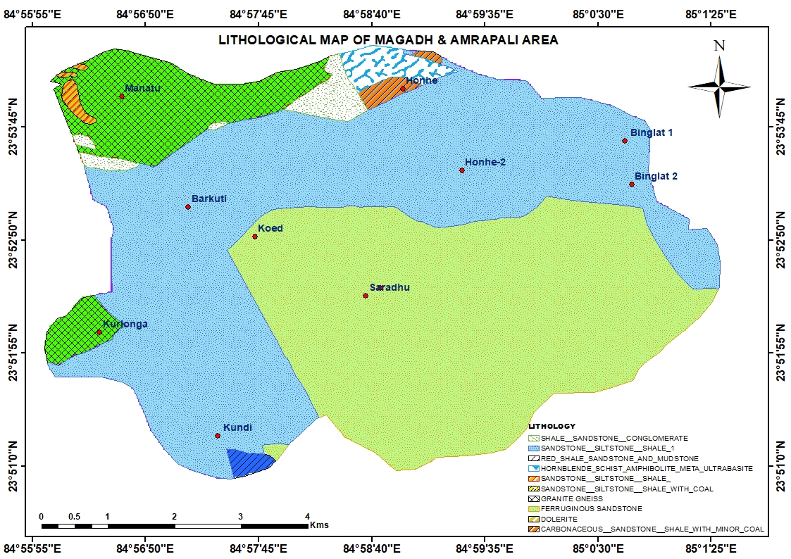

**Fig 2.5 Lithological map of Magadh & Amrapali Area**

**2.1.1.4 Hydrogeology**

The southern part of the district is underlain by Granite-gneiss of Achaean age forming the basement. These occur as large batholiths and are intruded by basic rocks. In the central and northern part of the district the rocks of Barakar formation consisting of feldspathic sandstones, shales and coal seams overlying the metamorphics are exposed. In the western and northern part of the district alluvial cover of moderate thickness, caps the Archaean crystalline and the Gondwana sedimentaries.

The district is underlain by diverse geological formations with complex tectonic framework.

The geological formations have been grouped under three main categories

1. The gneissic complex in the southern and the central part
2. The Rajmahal traps in the eastern and southeastern part

Gondwanas overlain by thin mantle of alluvial cover in the northern and central part. Ground water occurs mostly under phreatic condition in all the lithological units within the shallow aquifers and locally under semiconfined and confined condition in deeper aquifer.

Magadh and Amrapali coal mines are located in Chatra district in the Indian state of Jharkhand. These mines are operated by Central Coalfields Limited (CCL), a subsidiary of Coal India Limited, the largest coal-producing company in the world.

The Magadh and Amrapali coal mines are part of the North Karanpura coalfield, which is one of the largest coal reserves in India. The coalfield spans over an area of about 444 square kilometers and contains high-quality coal with low ash and sulfur content.

Mining in the Magadh and Amrapali areas involves open-pit mining methods. The extracted coal is primarily used for power generation, and a large portion of it is supplied to the national grid to meet the growing energy demand in India.

However, the impact of mining on the environment and local communities in the Chatra district has been a cause for concern. The extraction and processing of coal can result in the release of pollutants into the air and water, leading to environmental degradation and potential health hazards for nearby residents.

It is important to note that the government and the coal-producing companies have a responsibility to minimize the negative impact of mining on the environment and local communities.This can include implementing effective waste management practices, restoring damaged ecosystems, and providing compensation to affected communities.

**2.1.2 Barka Sayal Mining Area**

**Barka Sayal Area** is one of the operational areas of the [Central Coalfields Limited](https://en.wikipedia.org/wiki/Central_Coalfields) located mostly in the [Ramgarh](https://en.wikipedia.org/wiki/Ramgarh_district) district, with a small portion in [Hazaribagh](https://en.wikipedia.org/wiki/Hazaribagh_district) district, in the state of [Jharkhand](https://en.wikipedia.org/wiki/Jharkhand), India.

Barka Sayal Mining area lies in Toposheet No. 73E/2 and 73E/6, its comes within latitude 23o 38’51.52” N to 23o40’26.02” N and Longitude 85o19’42.88” E to 85o23’0.56” E

Bhurkunda colliery is an old mine operating in the [South Karanpura Coalfield](https://en.wikipedia.org/wiki/South_Karanpura_Coalfield) of Central Coalfields Ltd, in [Ramgarh district](https://en.wikipedia.org/wiki/Ramgarh_district).

State Railways started the mine in 1924. It was transferred to National Coal Development Corporation in 1956 and to CCL in 1973. A project report, covering both the underground and opencast mine, was prepared in 1959, for a production of 1.04 million tonnes per year. At that time mineable reserve was estimated at 99 million tonnes. A project report for reorganisation of Bhurkunda underground mine was prepared in 1996. As of 2016–17, Hathidari and Bansgarha seams were being worked by [bord and pillar](https://en.wikipedia.org/wiki/Room_and_pillar_mining" \o "Room and pillar mining) system of mining. Production from Bhurkunda underground mine was 1.43 lakh tonnes in 2012–13, 1.49 lakh tonnes in 2013–14, 0.85 lakh tonnes in 2014-15 and 1.02 lakh tonnes in 2015–16. The overburden from Balkudra open cast project is being dumped on the surface above the Hathidari an Bansgarha seams. Both the seams are classified as degree II for gassiness. In the project report, it is proposed to produce 0.3 million tonnes per year from Hathidari and Bansgarha seams. With an extractable reserve of 4.2 million tonnes in the two seams, the life of the mine is estimated to be around 20 years.

Bhurkunda open cast project consists of two blocks: Bhurkunda and Bhurkunda North Extension. The Bhurkunda block comprises a number of existing and discontinued underground and open cast workings. The entire Bhurkunda North Extension is a virgin area with a large built-up area belonging to CCL and some forest area to be acquired. The UG workings (separate from the UG mine project mentioned above) are waterlogged and discontinued. The OC workings are either waterlogged or dumped with overburden. Few galleries of abandoned and waterlogged UG workings of adjoining Saunda Colliery (in Sirka, Argada-A seams) are present in the area and as a precautionary measure a 60 m barrier is proposed. The normative production of the OCP project is proposed to be 1.75 million tonnes per year. With a mineable reserve of 9.3 million tonnes, the life of the mine is estimated to be 9 years, including 2 years of construction period.

Saunda D colliery was opened by Bird & Co. in 1946. Production from the underground mine in 2013-14 was 0.048 million tonnes. It is located in the [South Karanpura Coalfield](https://en.wikipedia.org/wiki/South_Karanpura_Coalfield) in the [Patratu (community development block)](https://en.wikipedia.org/wiki/Patratu_(community_development_block)" \o "Patratu (community development block)) in [Ramgarh district](https://en.wikipedia.org/wiki/Ramgarh_district). A new open cast mine was started in 1994–95.As of 2013, it had an annual production capacity of 0.93 million tonnes.[[3]](https://en.wikipedia.org/wiki/Barka_Sayal_Area#cite_note-3)

North Urimari open cast project is located in the northern portion of the [South Karanpura Coalfield](https://en.wikipedia.org/wiki/South_Karanpura_Coalfield) in the [Barkagaon (community development block)](https://en.wikipedia.org/wiki/Barkagaon_(community_development_block)" \o "Barkagaon (community development block)) in the [Hazaribagh district](https://en.wikipedia.org/wiki/Hazaribagh_district). The mine is divided into two parts by natural faults: Eastern and Western Quarries. In 1994, the project had obtained clearance for a production of 3 million tonnes per year. The total balance mineable reserves were estimated at 80.81 million tonnes.[[4]](https://en.wikipedia.org/wiki/Barka_Sayal_Area#cite_note-4)

Urimari underground project is located in the [South Karanpura Coalfield](https://en.wikipedia.org/wiki/South_Karanpura_Coalfield) in the [Patratu (community development block)](https://en.wikipedia.org/wiki/Patratu_(community_development_block)" \o "Patratu (community development block)) in [Ramgarh district](https://en.wikipedia.org/wiki/Ramgarh_district). In 1990, it had an approved production capacity of 0.36 million tonnes per year. The mine has been worked manually by the board and pillar method. In 2014, it was producing around 0.050 million tonnes per year. The balance mineable reserve in the mine was 3.55 million tonnes. If worked at the rated capacity, with some refurbishing, the mine will have a life of around 10 years. Subsequent mine closure plan has also been worked out.

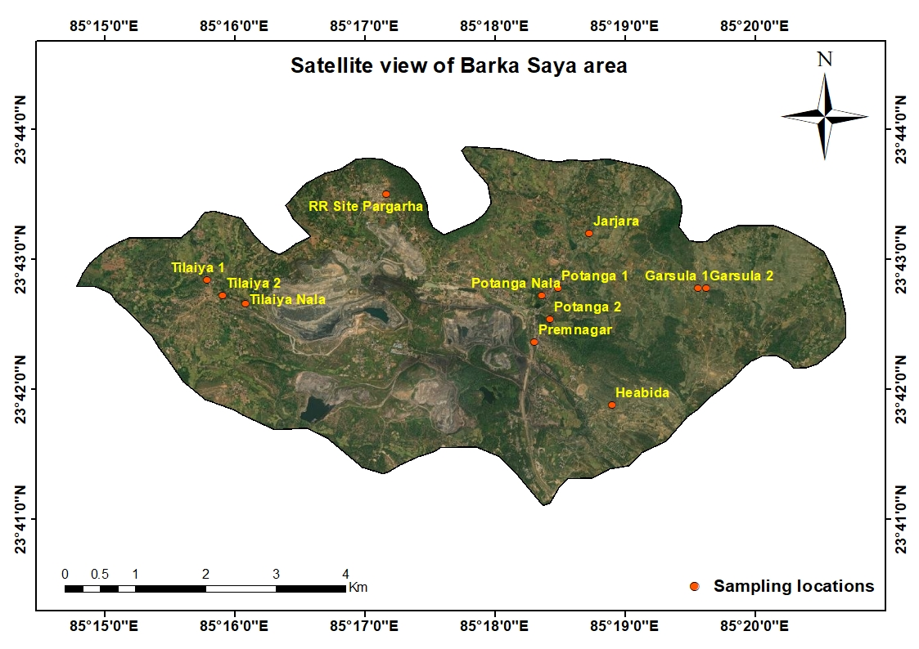

**Fig 2.6 Map shows satellite view of Barka Sayal Area**

**2.1.2.1 Topography of Barka Sayal Area**

Barka Sayal mining areas are located mostly in the [Ramgarh](https://en.wikipedia.org/wiki/Ramgarh_district) district, with a small portion in [Hazaribagh](https://en.wikipedia.org/wiki/Hazaribagh_district) district, in the state of [Jharkhand](https://en.wikipedia.org/wiki/Jharkhand), India. which is a region characterized by a rugged topography. The area is situated in the eastern part of India, and it is rich in mineral resources such as coal. The mining area in Ramgarh district is primarily located in the north and northwest parts of the district, and includes areas such as Barkakana, Kuju, Mandu, and Giddi. The landscape in these areas is dominated by hills and plateaus, with elevations ranging from 400 meters to 1,100 meters above sea level. The highest peak in the district is Parasnath Hill, which rises to a height of 1,366 meters.

The soil in the mining area is generally rocky and infertile, with a high proportion of minerals such as iron, coal, and limestone. The region is also prone to erosion and landslides due to its hilly terrain and heavy rainfall during the monsoon season.

The topography of the region is characterized by undulating hills and plateaus with elevations ranging from 200 to 700 meters above sea level. The district is situated in the Damodar valley and is drained by the Damodar River and its tributaries.

Mining is a major economic activity in Ramgarh district, with several coal mines operating in the region. The mining operations have caused significant environmental and social impacts, including deforestation, land degradation, displacement of local communities, and pollution of air and water resources. The government and mining companies have been working to mitigate these impacts through various environmental and social welfare measures.

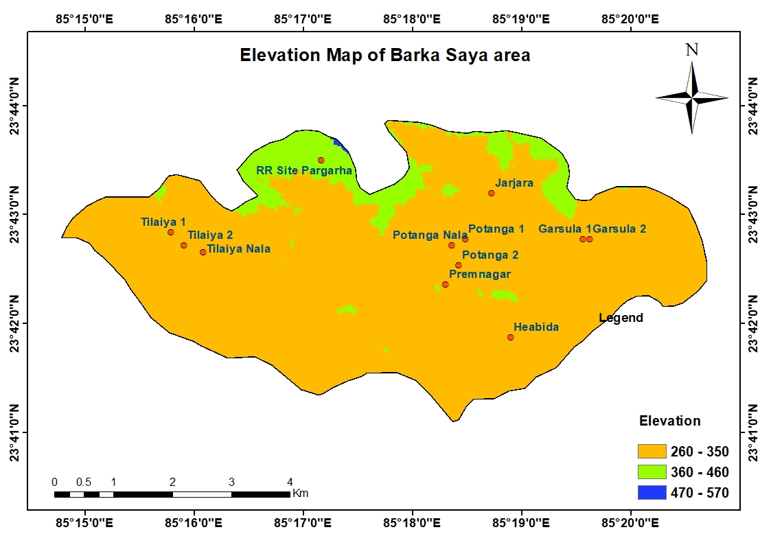

**Fig 2.7 Elevation map of Barka Sayal Area**

**2.1.2.2** **Climate**

The area lies in the sub-humid region of Chotanagpur Plateau and enjoys semi-extrem type of climate. The day temperature rises around 40°C during the summers and drops down to around 8°C during the winter.

**2.1.2.3 Drainage pattern**

Damodar is the Main River of the district and it also forms a major river basin, comprising a number of tributaries. Important amongst them are: Naikari drainage from south & join Damodar.

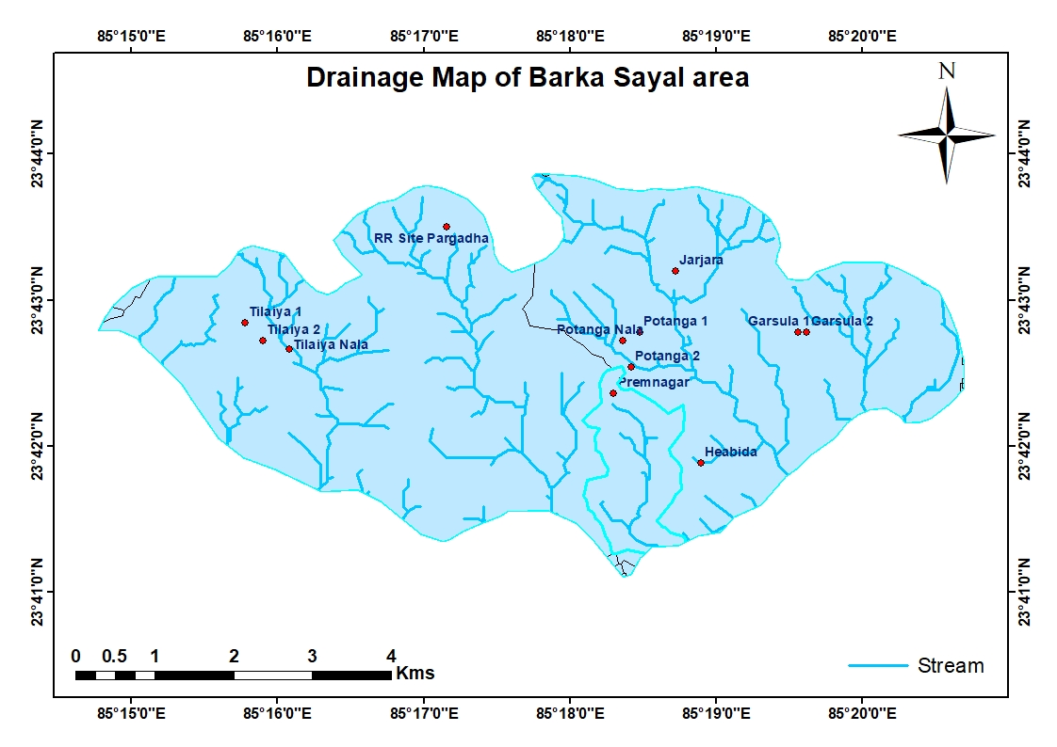

**Fig 2.8 Drainage Map of Barka Sayal mining Area**

##### **2.1.2.4 Geomorphology and Soil types:**

The district is a part of Chotanagpur plateau. Important physiographic regions of the district is Damodar Valley Major area of the district come under Damodar. Valley.Damodar Valley is bounded by [Hazaribag](http://en.wikipedia.org/wiki/Hazaribag) Plateau in north and [Ranchi](http://en.wikipedia.org/wiki/Ranchi) Plateau in south .Ranchi and Hazaribag plateau is separated by East-West running Damodar valley. Barka Pahar (Marang Buru)1049 meters high above sea level located along the Ramgarh-Ranchi border is probably the highest Peak and it also separate both district.

Mainly two type of soil found -Red Soil and Sandy loam. Three soil orders namely Entisols, Inceptisols and Alfisols were observed in the district.

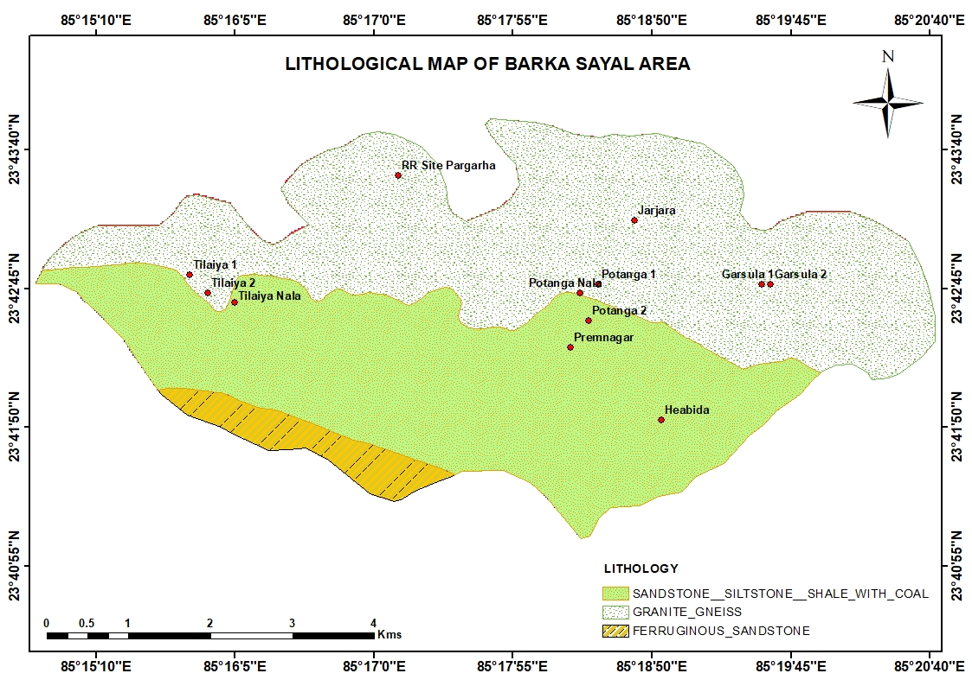

**Fig 2.9 Lithological map of Barka Sayal Area**

**2.1.2.5 Hydrogeology**

The district is having varied hydrogeological characteristics due to which ground water potential differs from one region to another. It is underlain by Chotanagpur granite gneiss of pre-Cambrian age in three-fourth of the district.

The Barka-Sayal-Ramgarh district is located in the Indian state of Jharkhand and is known for its abundant coal reserves. The district is home to several coal mines that are operated by Coal India Limited, the largest coal-producing company in the world.

Coal mining in the Barka-Sayal-Ramgarh district involves both underground and open-pit mining methods, and the extracted coal is primarily used for power generation. The district is considered to have high-quality coal with low ash and sulfur content, making it highly sought after for use in the energy sector. However, the impact of coal mining on the environment and local communities in the Barka-Sayal-Ramgarh district has been a source of concern. The extraction and processing of coal can result in the release of pollutants into the air and water, leading to environmental degradation and potential health hazards for nearby residents.

In addition, the large-scale removal of vegetation and topsoil during the mining process can have significant impacts on local ecosystems and wildlife. The displacement of local communities and loss of traditional livelihoods is also a concern

in the area.

**2.2. IDENTIFICATION OF SAMPLING LOCATIONS**

A total of 46 well and hand pump water samples were collected using water level recorder from both the selected locations i.e., Barka Sayal and Magadh and Amrapali coal mine areas during pre-monsoon and post-monsoon period.

**Table 2.1 Number of sampling locations**

|  |  |  |  |  |  |
| --- | --- | --- | --- | --- | --- |
| **Types of Water** | **Number of locations** | **Instruments** | **Seasons (Pre & Post monsoon)** | **Total no. of Samples** | |
| Groundwater(well) | 23 | Water level Recorder | 2 | 46 | |
| **Total** | | | | | **46** |

**2.2.1. Details of sampling locations of Magadh & Amrapali Area:**

**Table 2.2 Sampling locations of Magadh and Amrapali area with latitude and longitude**

|  |  |  |  |
| --- | --- | --- | --- |
| **Sl. No.** | **Location Name** | **Longitude** | **Latitude** |
| 1 | Kundi | 84° 57' 24.48" | 23° 51' 15.84" |
| 2 | Kurlonga | 84° 56' 26.52" | 23° 52' 4.44" |
| 3 | Manatu | 84° 56' 11.4" | 23° 53' 7.44" |
| 4 | Barkuti | 84° 57' 9.72" | 23° 53' 7.08" |
| 5 | Koed | 84° 57' 44.28" | 23° 52' 50.88" |
| 6 | Saradhu | 84° 58' 36.84" | 23° 52' 22.8" |
| 7 | Saradhu Nala | 84° 58' 36.84" | 23° 52' 36.84” |
| 8 | Honhe – 1 | 84° 58’ 56.28” | 23° 54’ 3.6” |
| 9 | Honhe – 2 | 84° 59’ 23.28” | 23° 53’ 22.56” |
| 10 | Binglat – 1 | 84° 57’ 56.88” | 23° 51’ 46.08” |
| 11 | Binglat -2 | 84° 58’ 17.04” | 23° 53’ 17.16” |

**2.2.2. Details of** **sampling location of Barka Sayal Area:**

**Table 2.3 Sampling locations of Barka Sayal area with latitude and longitude**

|  |  |  |  |
| --- | --- | --- | --- |
| **Sl. No.** | **Location Name** | **Longitude** | **Latitude** |
| 1 | Premnagar | 85° 18’ 16.92” | 23° 42’ 21.6” |
| 2 | Potanga – 1 | 85° 18’ 44.64” | 23° 43’ 13.08” |
| 3 | Jarjara | 85° 18’ 27.36” | 23° 42’ 47” |
| 4 | Garsula – 1 | 85° 19’ 32.52” | 23° 42’ 45” |
| 5 | Garsula-2 | 85° 20’ 30.48” | 23° 42’ 45.36” |
| 6 | Tilaiya Nala | 85° 18’ 56.88” | 23° 42’ 53.28” |
| 7 | Heabida | 85° 18’ 52.2” | 23° 41’ 53.16” |
| 8 | Tilaiya-1 | 85° 15’ 45.72” | 23° 42’ 49.68” |
| 9 | Tilaiya-2 | 85° 17’ 4.56” | 23° 42’ 22.32” |
| 10 | Potanga – 2 | 85° 17’ 3.84” | 23° 43’ 0.84” |
| 11 | RR Site Pargadha | 85° 17’ 8.88” | 23° 43’ 28.56” |
| 12 | Potanga Nala | 85° 17’ 20.76” | 23°42’ 28.8” |

**CHAPTER 3**

***Laboratory Analysis and Field Work***

***WORK COMPLETED TILL DATE***

**LABORATORY TESTS AND FIELD WORK**

**3**

**3.1 Preparation of Base Map**

Topographic maps of 1:50,000 scales surveyed by SOI in 1973-81 were used to prepare the base map The study area is covered by Toposheet no. 73A/3, 73E/2 and 73E/6 on 1: 50,000 scale. All these maps were electronically scanned and converted to raster data. Digitization of raster map features was performed through the Arc GIS Software 10.5, which is a module in the Intergraph GIS. Geo-referencing of all the maps was done before performing digitization. This involves giving an address to the study area in the GIS with respect to its geographical location, i.e. latitudes and longitudes.

**3.2 Collection of Groundwater Samples**

For the hydro-geochemical study of the Magadh & Amrapali Mining Area Located in Chatra District and Barka Sayal Mining Area mostly in Ramgarh and small part in Hazaribagh District a systematic sampling was carried out during the month of May 2022 and December 2022 . The sampling locations were selected to cover the entire study area and attention had been given to the areas where pollution was expected. In this study, the groundwater resource sampling networks were selected as per the geological formations of the study area. Forty Six of the groundwater samples (Twenty three samples in the post-monsoon season, and twenty three samples in the pre-monsoon season) were collected from different sites of the study area in 1000 ml clean plastic containers, following the procedures of APHA (2012), for understanding the factors responsible for variations of aquifer chemistry and also for assessing the groundwater quality for drinking, irrigation and industrial purposes.

The sampling bottles soaked in 1:1 HCl for 24 hours were rinsed with distilled water, followed by deionized water. They have washed again prior to each sampling of the filtrates.

**(Shown in photo no. 1)**

**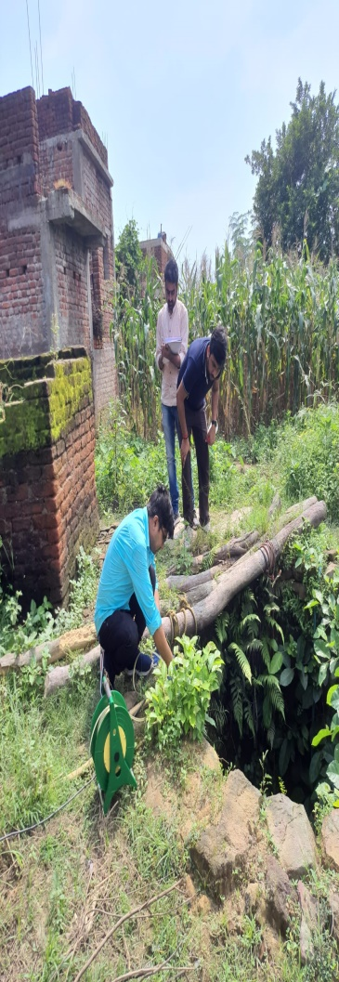 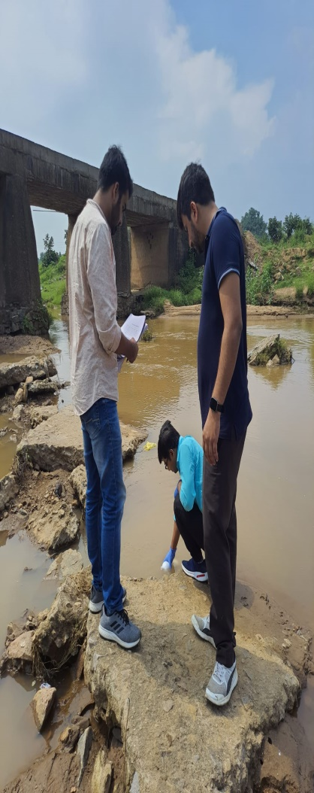** 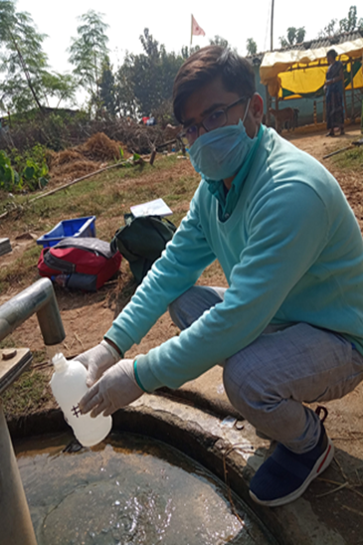

**Photo 1. Photographs clicked during water sample collection at sampling location**

**3.3 Analytical methods**

Analysis of water samples were carried out in the laboratory at Department of Environmental Science and Engineering, Indian School of Mines and CSIR- Central Institute of Mining and Fuel Research, Dhanbad as per Standard Methods (APHA, 2005). In the laboratory, the water samples were filtered through 0.45 μm Millipore membrane filters to separate suspended particles. The pH and electrical conductivity was measured by using CONSORT multi-parameter analyzer. Acid titration method was used to determine the concentration of bicarbonate (HCO3-) in water samples. Dissolved silica was measured by UV-Visible spectrophotometric methods (SHIMADZU, UV-2550).

Major anions (F-, Cl-, SO42-,and NO3-) were estimated by ion chromatograph (Dionex - DX 120) and major cations (Ca 2+, Mg2+, Na+,and K+) by atomic absorption spectrophotometer (AAS) and flame photometer (Table 3.1). The details of field and analytical methods are summarized in Figure 4.4and has been discussed below.

**Table 3.1 Physicochemical with there testing instrument**

|  |  |
| --- | --- |
| **Chemical parameters** | **Methods** |
| Hydrogen ion concentration (pH) | pH meter |
| Specific electrical conductivity (SEC) | EC meter |
| Total dissolved solids | SEC× conversion factor (0.55 to 0.75) |
| Total hardness (TH) | Titration with EDTA |
| Calcium (Ca2+) | Titration with EDTA |
| Magnesium (Mg2+) | Calculation (TH-Ca2+) |
| Sodium (Na+) | Flame photometer |
| Phosphate(PO43- ) | Spectrophotometer |
| Bicarbonate (HCO3-) | Titration with HCl |
| Chloride (Cl-) | Titration with AgNO3 |
| Sulfate (SO42-) | Spectrophotometer |
| Nitrate (NO3-) | Spectrophotometer |

**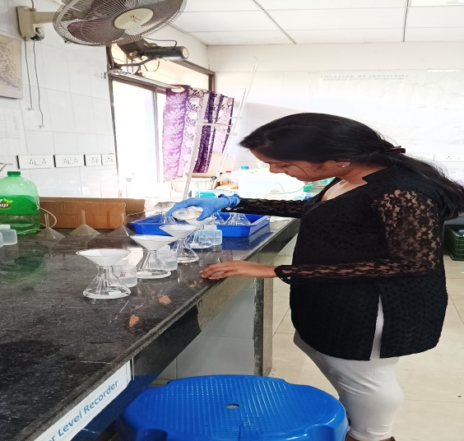**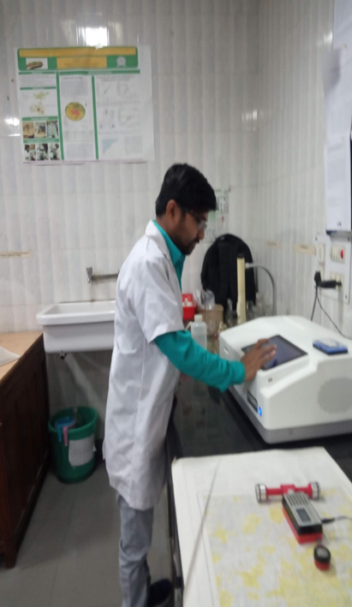

(b)

(b)

(a)

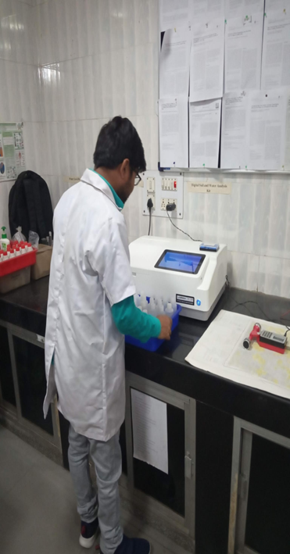

**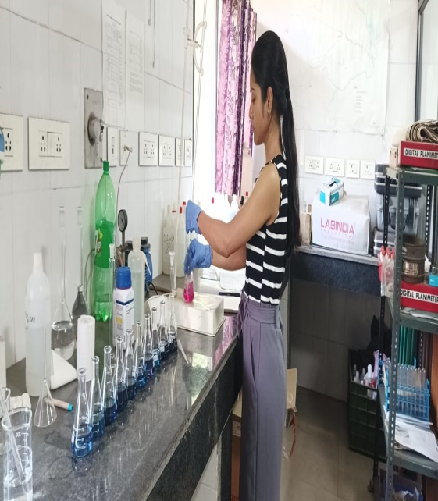**

(d)

(c)

**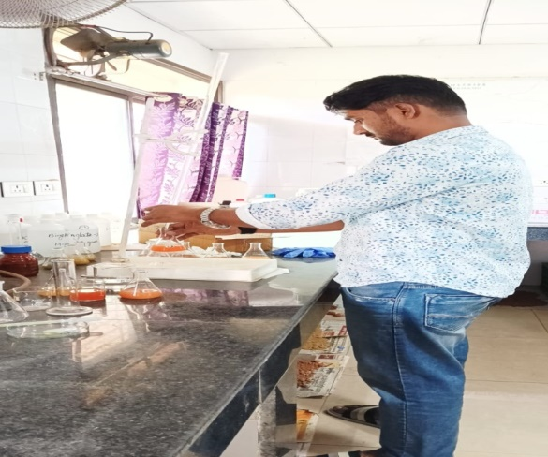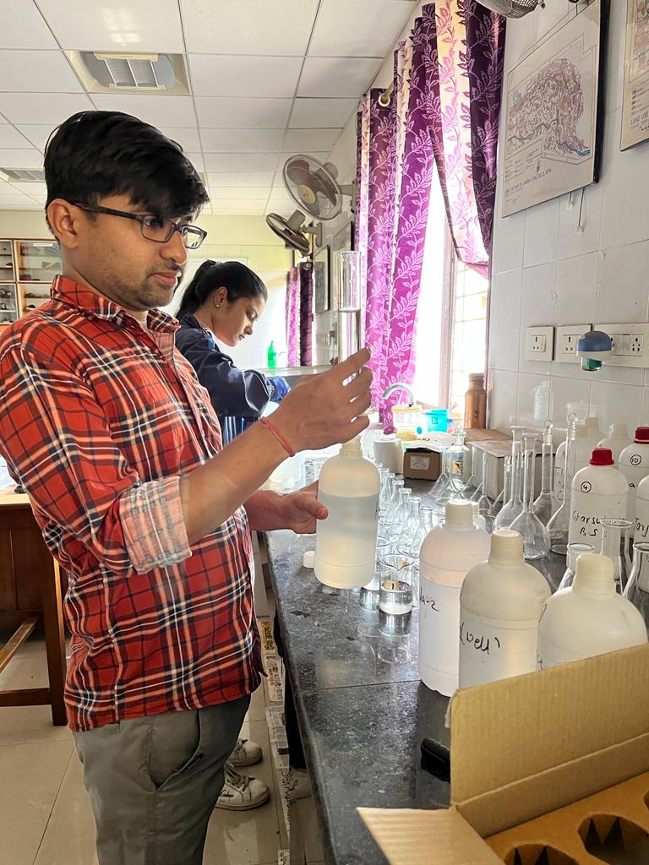**

(e)

(f)

**Photo 2. a, b, c, d, e, f During testing of water sample in Lab**

**3.3.1 pH:**

pH is a measurement of the intensity of acidity or alkalinity and the concentration of H+ ions in a water sample. It is generally measured on a log scale and equal to negative log10 of hydrogen ions concentration.

**pH = -log[H+]**

The result of pH measurement are presented on a numerical scale ranging from o to 4, water with in the range of 0 to 7 are acidic and those b/w 7to 14 are alkaline, while pH – 7 indicate neutrality. Most of the natural water is generally alkaline due to the presence of sufficient quantity of carbonates. Significant changes in pH occur due to disposal of industries and domestic waste. In natural water, pH also changes seasonally due to variation in photosynthesis activity, which increases the pH due to the consumption of CO2 in the process. pH was measured using pH meter. The pH is determined by measurement of electromotive force (e.m.f) of a cell containing an indicator electrode immersed in the test solution and a reference electrode (calomel electrode). Electrode was washed with distilled water and was calibrated against standard buffer solution of 4.0, 7.0 and 9.2. Electrode was washed with distilled water after calibrating with each buffer solution. After calibration the washed electrode was placed in the sample. Equilibrium was established between electrode and sample by stirring sample to ensure homogeneity**.**

**3.3.2 Electrical Conductivity**

Electrical conductivity was measured by using CONSORT E.C. meter. It provides measurement of E.C. by a cell consisting of two platinum electrodes to which an alternating potential is applied. The corresponding is proportional to conductivity of the ionic solution in which cell is applied. For E.C. measurement, the instrument was calibrated and set for 0.01N KCL standard. The conductivity was measured in µS/cm for water samples.

**3.3.3 Turbidity**

Suspension of particles in water interfering with passage of light is called turbidity. Turbidity of the samples was analyzed by using turbidity meter. Turbidity meter was calibrated with the help of standard supplied of 0.2, 20 and 200 NTU. Turbidity in the samples was measured by the turbidity meter after calibration.

**3.3.4 Total Dissolved Solids (TDS)**

In natural water dissolved solids are consists of inorganic salts, small amount of organic matter and dissolved material in natural water. Dissolved solids are mainly due to carbonates, chlorides, sulphates, nitrates, phosphates, Ca, Mg, Na, K, Fe, Mn, etc. The material remains in the water after filtration for the suspended solids analysis considered to be dissolved. A well-mixed, measured portion of sample was filtered in an initially weighed beaker through standard Whatman No. 42 filter paper and the filtrate portion was evaporated to dryness on the hot plate. The hot beaker was desiccated for 1hour. Then final weight of the beaker was taken. Final minus initial weight of the beaker gives the amount of total dissolved solids.

**Calculation:**

Total dissolved solids (TDS) mg l-1 = (W2 – W1) x 1000 x 1000) / V

Where,

W1 = initial weight of the evaporating dish (g) W2 = final weight of evaporating dish (g).

V = volume of the sample taken (ml).

Concentration of dissolved solids is an important parameter in drinking water and other water quality standard. A dissolved solid contribute a particular taste to the water at concentration near 300mg l-1 The water with high dissolved solids is not even suitable for irrigation because it increases the salinity of the soil.

**3.3.5 Total Hardness**

Hardness is the properties of water by which it prevents the lather formation with soap and increasing the boiling point of water. The principal cation causing hardness in water and major anions associate with them are listed below in Table 4.4.

**List of ions causing Hardness**

|  |  |
| --- | --- |
| Cations causing hardness | Associated anions |
| Ca++ | HCO3- |
| Mg++ | SO4- - |
| Sr++ | Cl- |
| Fe++ | NO3- |
| Mn++ | SiO3- |

**Table 3.2 Ions causing Hardness**

Hardness is temporary if it is caused by bicarbonate and carbonates salt of the cations and permanent if caused by sulphates and chloride of the metal. Hardness of water varies considerably from place to place.

In general, surface water is softer than ground water. Total hardness was measured directly by titration with Ethylene-Di-Amine-Ttra acetic acid (EDTA) using Eriochrome Black-T (EBT) as an indicator. The EBT reacted with the divalent metallic Cations, forming a complex that was red in colour. The EDTA replaces EBT in the complex, and when the replacement was complete the solution changes from red to blue. This was end point of titration; the burette reading was noted for further

**Calculation:**

Hardness (EDTA) as mg l-1 calcium carbonate = (Ax100)/V Where, A = ml of titrant used.

V = ml of sample

1. Buffer solution :16.9gm NH4CL in 143 ml of conc. NH4OH and 1.25gm EDTA Mg salt is added OR 1.179gm Na2 EDTA and 0.780gm MgSO4.7H2O and dilute to 250 ml.
2. EDTA (0.01M):3.728gm EDTA in 1litre of distilled water.
3. Erichrome Black T indicator:

Hardness has no adverse effects on health. Hard water is not suitable for domestic use in washing, and laundering. Hardness may be advantageous in certain condition; it prevent the corrosion in the pipe by forming a layer of scale.

**3.3.6 Alkalinity**

Alkalinity of the water is its capacity to neutralize a strong acid and is characterized by presence of all hydroxyl ions capable of combining with hydrogen ions. Alkalinity in natural water is due to presence of free OH- ions and hydrolysis of salts formed by weak acids and strong bases. Most of the alkalinity in natural water is formed due to the dissolution of carbon dioxide in water carbonate salt produce double the hydroxyl ion than bicarbonates.

**Procedure**:

25 ml of sample was taken in a flask and to it 2–3 drops of phenolphthalein indicator was added to it. The color changed to pink; it was then titrated with 0.02N HCL, till orange color disappears. After phenolphthalein indicator added color is not appearing i.e. P.A is zero. After those 2-3 drops of Methyl Orange was added to the sample the color changed to Orange color continued titration with 0.02N HCL, till orange color change to pink. The volume of HCL consumed was noted from the Burette for further calculation as follows

Alkalinity in itself is not harmful to human being, but less than 100mg/l are desirable limits for domestic use. The alkalinity value is also important in calculating the dose of alum. Alkalinity producing substance, are added to check corrosion in soft water supplies

**Calculation**

Total alkalinity mg l-1 =

Where A = Phenolphthalein reading, B= Methyl orange reading.

**Reagents:**

1. Methyl Orange indicator
2. Sodium Carbonate Solution (1N): 13.25gm anhydrous Na2Co3 (dried at 1400C).

Dissolve it in little D/W and make up to 250ml in volumetric flask

1. Sulphuric acid 1N: place 28ml conc. H2SO4 in a volumetric flask and make up to the mark with CO2 free D/W Standardize it against 1N sodium carbonate solution.
2. Sulphuric acid 0.02N: Dilute 1N H2SO4 (about 20ml) to 1000ml in a volumetric flask with CO2 free D/W.

**3.3.7 Chloride**

Chloride occurs naturally in all types of water. In natural fresh water the concentration is quite low. The important source of chloride in the water is the discharge of domestic sewage. Man and animal excretes very high quality of chloride together with nitrogenous compounds. Chlorides are highly soluble in water so they do not get precipitate and cannot be removed by biological treatment of water.

**Procedure**:

Chloride in the sample was measured directly by titrating 50 ml of sample with 0.02N AgNO3 solution using 2 ml of 5% K2Cr2O4 solution. The colour changes from yellow to brick red, which was the end point of the titration. Amount of AgNO3 consumed in the cases was noted for further calculation:

**Calculation**

Chloride as Cl2 mg l-1 = Where,

T=ml of titrant (AgNO3) required for sample in ml,

N=normality of titrant (AgNO3)

**Reagents and Standards:**

1. Potassium chromate indicator: Dissolve 50 gm K2CrO4 in distilled water add AgNO3 till formation of precipitate. Allow to stand for 12 hours. Filter and dilute to 1000ml .
2. Silver Nitrate (0.0141N): Dissolve 2.395 gm AgNO3 and dilute to 1000ml.

Standardized against NaCl (0.0141N). 1ml of 0.014N AgNO3 = 0.5mg Cl.

**3.3.8 Bicarbonate:**

Bicarbonate was determined by following potentiometer titration method. Standards of HCO3 were prepared for concentration ranging from 100 to 800 ppm. 50 ml of each standard and samples were titrated against 0.3 N HCl. pH 4.5 is taken as the endpoint of the reaction. A graph was plotted for standard concentrations against the volume of HCl consumed. The concentration of the samples was determined from the graph plotted for the standards.

**3.3.9 Sulphate**

Sulphate ion concentration was measured by turbid metric method. The method was based on the principle that SO4 was precipitated in an acid medium with Barium Chloride (BaCl2), so as to form barium sulphate crystal of uniform size. Light absorption of barium sulphate suspension was measured by UV-VIS Spectrophotometer and the concentration was determined by comparison of the reading with the standard curve.50 ml sample were measured in volumetric flask and 5ml of buffer solution (prepared by dissolving 30gm MgCl2.6H2O, 5gm CH3COONa.3H2O, 1g KNO3, 20 ml acetic acid in 500 ml distilled water made up to 1000ml) was added and mixed with the help of magnetic stirrer. While stirring spoonful of BaCl2 crystal was added and it was stirred for 60 seconds with constant speed. After the stirring period solution was poured into the absorbance cell of the UV Spectrophotometer and absorbance reading was taken at 420 nm after 5 minutes. Sulphate ion concentration was determined by comparison reading with calibration curve prepared by carrying sulphate standard through the entire procedure.

**Reagents**

i) Buffer Solution: Dissolved 30g MgCl2.6H2O + 5g CH3COONa.3H2O + 1g KNO3 + 20 ml CH3COOH (99%) in 500 ml distilled water then make up the volume 1000 ml. by distilled water. ii) Standard sulphate solution (1000 ppm): Dissolved 1.479 g Na2SO4 in 1000 ml distilled water.

Major cations (Ca, Mg, Na, and K) were also measured by the Varian AAS by using different chemical standards. The analytical results of AAS and Ion Chromatograph are found to be comparable and within acceptable limits (<5%).

**Principles**

The technique makes use of absorption spectrometry to assess the concentration of an analyte in a sample. It relies therefore heavily on Beer-Lambert law. In short, the electrons of the atoms in the atomizer can be promoted to higher orbitals for an instant by absorbing a set quantity of energy (i.e. light of a given wavelength). This amount of energy (or wavelength) is specific to a particular electron transition in a particular element, and in general, each wavelength corresponds to only one element. This gives the technique its elemental selectivity. As the quantity of energy (the power) put into the flame is known, and the quantity remaining at the other side (at the detector) can be measured, it is possible, from Beer-Lambert law, to calculate how many of these transitions took place, and thus get a signal that is proportional to the concentration of the element being measured. In order to analyze a sample for its atomic constituents, it has to be atomized. The sample should then be illuminated by light. The light transmitted is finally measured by a detector. In order to reduce the effect of emission from the atomizer (e.g. the black body radiation) or the environment, a spectrometer is normally used between the atomizer and the detector. The technique typically makes use of a flame to atomize the sample, but other atomizers such as a graphite furnace or plasmas, primarily inductively coupled plasmas, are also used. When a flame is used it is laterally long (usually 10 cm) and not deep. The height of the flame above the burner head can be controlled by adjusting the flow of the fuel mixture.

**There are several factors that can affect water stress in mining areas, some of the most important ones include:**

1. **Water demand:** High demand for water in mining activities can lead to water scarcity and stress in the region, especially in areas with limited water resources.
2. **Water contamination:** Mining activities can result in the contamination of water sources, making them unsuitable for drinking, irrigation, or other uses.
3. **Surface and ground water depletion:** Extensive pumping of ground and surface water sources for mining operations can lead to depletion of these sources and increase water stress.
4. **Poor water management practices:** Inadequate water management practices, such as over-extraction, inefficient use, and lack of treatment facilities, can contribute to water stress in mining areas.
5. **Competition for water resources:** Competition between mining operations, agriculture, and other industries for water resources can increase water stress in the region.
6. **Environmental regulations:** Strict environmental regulations and water quality standards can limit the availability of water for mining operations and contribute to water stress. It's important to note that the level of water stress in a mining area depends on a variety of factors, and the impact of these factors can vary depending on the specific region and its unique characteristics.

**CHAPTER 4**

***Systematic Monitoring of Water Level Fluctuations***

****

**4**

**MONITORING OF WATER LEVEL AND WATER TABLE FLUCTUATIONS**

#### 4.1 Water Table fluctuation

#### The water table fluctuation refers to the rise and fall of the groundwater level in response to various factors such as precipitation, evapotranspiration, and pumping of groundwater for various purposes. The seasonal variation of water table fluctuation is influenced by various factors such as rainfall patterns, temperature, soil type, and vegetation cover. The details of seasonal variation of water table fluctuation are discussed below:

#### Summer: During the summer season, the water table fluctuation tends to be at its lowest point due to increased evapotranspiration, which causes a reduction in groundwater levels. The higher temperatures and reduced rainfall also contribute to the lowering of the water table.

#### Winter: The water table fluctuation during winter is similar to that of fall, but with decreased rates of evapotranspiration, the groundwater levels may remain stable or even rise slightly due to precipitation from snow and rain.

**Identification of Sampling Locations**

**GIS Geostatistical Interpolation**

**Pre-Monsoon**

**Collection of water level data**

**Post-Monsoon**

**Spatial map of water level and water level fluctuation**

**Discussion and Conclusion**

#### 

#### Figure 4.1 Flow chart of adopted research work

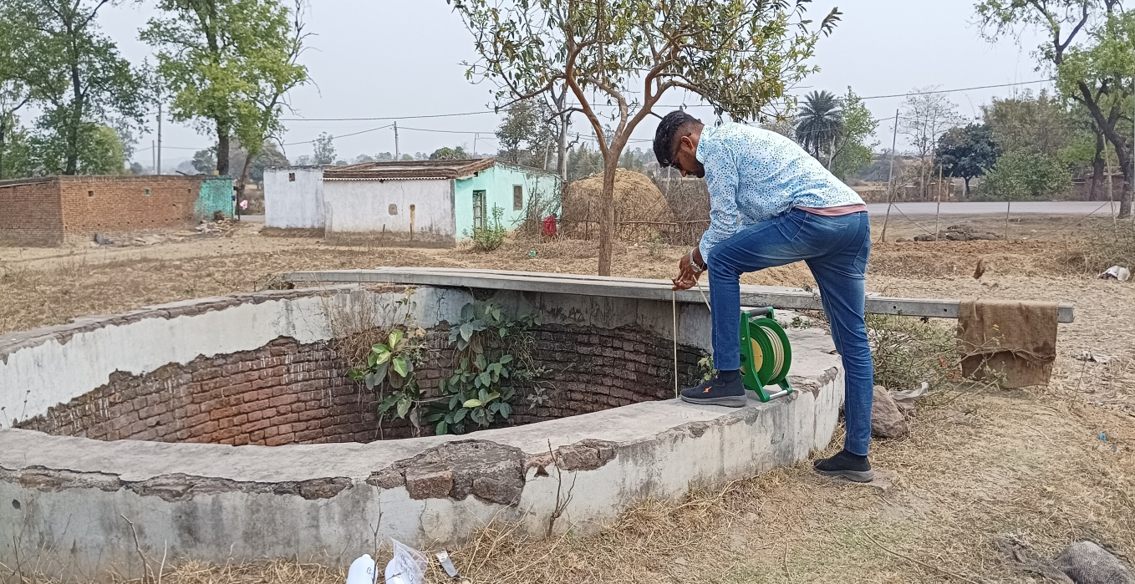

**Binglat, Amrapali area**

**Binglat, Magadh & Amrapali**

(a)

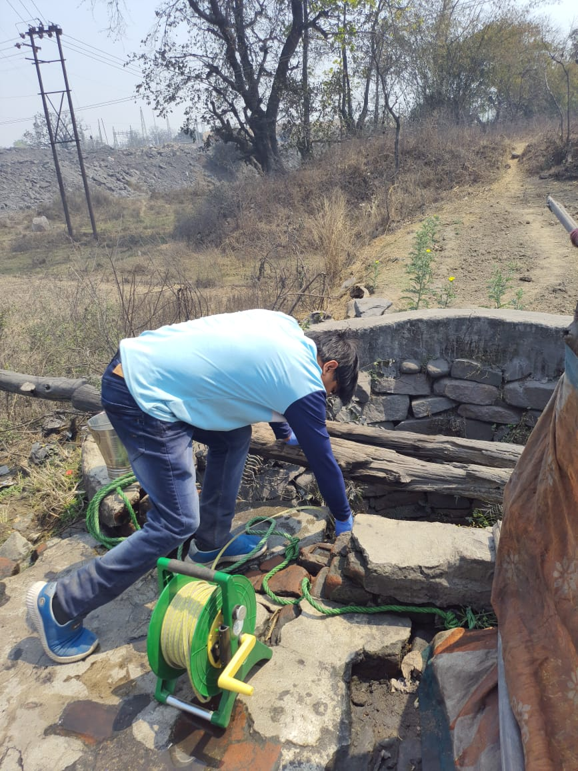 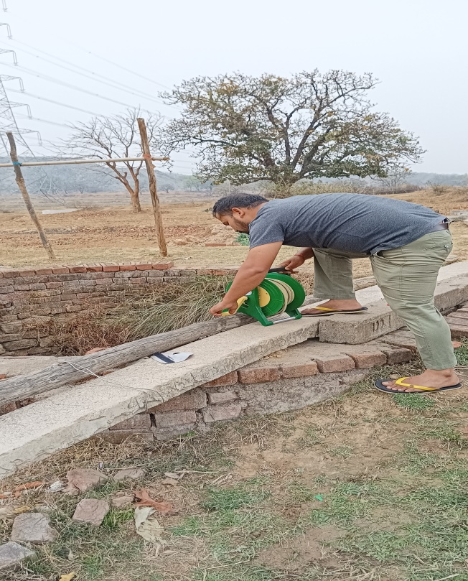

**Kundi, Magadh & Amrapali**

**Potanga, Barka Sayal**

(b) (c)

**Photo 3 a, b, and c Measuring of water level by Water level Sounder**

#### 4.2. Water table fluctuation in Barka Sayal area

#### The water table fluctuation data of Baraka Sayal was noted during pre-monsoon (May – June 2022) in Table 4.2 and 4.3 and post – monsoon (November 2022 – January 2023) in table 4.4, 4.5, 4.6 from he below mentioned locations in Table 4.1.

#### Table 4.1 Locations details and sources of water samples from Barka Sayal area

|  |  |  |  |  |
| --- | --- | --- | --- | --- |
| **Sample No.** | **Latitude** | **Longitude** | **Village** | **Source** |
| 1 | 23.706 | 85.304 | Premnagar | Well |
| 2 | 23.713 | 85.307 | Potanga 1 | Well |
| 3 | 23.720 | 85.312 | Jarajra | Well |
| 4 | 23.712 | 85.325 | Garsula 1 | Well |
| 5 | 23.712 | 85.341 | Garsula 2 | Well |
| 6 | 23.716 | 85.312 | Tilaiya Nala | SW |
| 7 | 23.698 | 85.314 | Heabida | Well |
| 8 | 23.713 | 85.262 | Tilaiya 1 | Well |
| 9 | 23.706 | 85.284 | Tilaiya 2 | HP |
| 10 | 23.716 | 85.284 | Potanga 2 | Well |
| 11 | 23.723 | 85.285 | RR Site Pargarha | Well |
| 12 | 23.708 | 85.289 | Potanga Nala | SW |

#### Table 4.2 Monitoring of water level (mbgl) in May, 2022

|  |  |  |  |
| --- | --- | --- | --- |
| S.No. | Location | Source | Water Level (mbgl) |
| 1 | Premnagar | Well | 4.9 |
| 2 | Jarajra | Well | 5.62 |
| 3 | Garsula | Well | 4.25 |
| 4 | Telaiya | Well | 8.35 |
| 5 | Potanga | Well | 5.6 |
| 6 | R.R Site, Pargarha | Well | 8.95 |
| 7 | Haebida | Well | 8.95 |

#### Table 4.3 Monitoring of water level (mbgl) in June,2022

|  |  |  |  |
| --- | --- | --- | --- |
| S.No. | Location | Source | Water Level (mbgl) |
| 1 | Premnagar | Well | 5.6 |
| 2 | Jarajra | Well | 6.12 |
| 3 | Garsula | Well | 6.63 |
| 4 | Tilaiya | Well | 9.61 |
| 5 | Potanga | Well | 7.32 |
| 6 | R.R Site, Pargarha | Well | 9.2 |
| 7 | Heabida | Well | 9.38 |

#### Table 4.4 Monitoring of water level (mbgl) in November,2022.

|  |  |  |  |
| --- | --- | --- | --- |
| S.No. | Location | Source | Water Level (mbgl) |
| 1 | Premnagar | Well | 2.6 |
| 2 | Jarajra | Well | 3.12 |
| 3 | Garsula | Well | 1.03 |
| 4 | Tilaiya | Well | 1.02 |
| 5 | Potanga | Well | 1.92 |
| 6 | R.R Site, Pargarha | Well | 2.23 |
| 7 | Heabida | Well | 1.43 |

|  |  |  |  |
| --- | --- | --- | --- |
| S.No. | Location | Source | Water Level (mbgl) |
| 1 | Premnagar | Well | 2.8 |
| 2 | Jarajra | Well | 3.30 |
| 3 | Gharsula | Well | 1.28 |
| 4 | Tilaiya | Well | 1.56 |
| 5 | Potanga | Well | 2.3 |
| 6 | R.R Site, Pargarha | Well | 3.02 |
| 7 | Heabida | Well | 2.06 |

#### Table 4.5 Monitoring of water level (mbgl) in January, 2023

#### 4.2.1. Average Water Level Fluctuation of Barka Sayal (Pre-monsoon and Post-monsoon period)

#### The table 4.7 mentioned below exhibits the average of the water level fluctuations during pre-monsoon and post-monsoon seasons .

#### 

#### Table 4.6 Water level fluctuation of Barka Sayal Area

|  |  |  |  |  |  |
| --- | --- | --- | --- | --- | --- |
| S.No. | Location | Source | Premonsoon (mbgl) | Post monsoon (mbgl) | WLF(mbgl) |
| 1 | Premnagar | Well | 5.25 | 2.7 | 2.55 |
| 2 | Jarjara | Well | 5.87 | 3.21 | 2.66 |
| 3 | Garsula | Well | 5.44 | 1.155 | 2.23 |
| 4 | Tilaiya | Well | 8.98 | 1.29 | 7.69 |
| 5 | Potanga | Well | 6.46 | 2.11 | 4.35 |
| 6 | R.R Site, Pargarha | Well | 9.075 | 2.625 | 6.45 |
| 7 | Heabida | Well | 9.165 | 1.745 | 7.42 |

#### 4.3. Water table fluctuation in Magadh & Amrapali area

#### The water table fluctuation data of Barka Sayal was noted during pre-monsoon (May 2022 – June 2022) and post-monsoon (November 2022 – January 2023 and March 2023) in Table 4.11, $.12 and 4.13 from the below mentioned locations in Table 4.8.

#### Table 4.7 Locations details and Source where water collected of Magadh & Amrapali area

|  |  |  |  |  |
| --- | --- | --- | --- | --- |
| **Sample No.** | **Latitude** | **Longitude** | **Village** | **Source** |
| 1 | 23.706 | 85.304 | Kundi | Well |
| 2 | 23.713 | 85.307 | Kurlonga | Well |
| 3 | 23.720 | 85.312 | Manatu | HP |
| 4 | 23.712 | 85.325 | Barkuti | Well |
| 5 | 23.712 | 85.341 | Koed | Well |
| 6 | 23.716 | 85.312 | Saradhu | SW |
| 7 | 23.698 | 85.314 | Saradhu Nala | Well |
| 8 | 23.713 | 85.262 | Honhe – 1 | Well |
| 9 | 23.706 | 85.284 | Honhe – 2 | HP |
| 10 | 23.716 | 85.284 | Binglat – 1 | Well |
| 11 | 23.723 | 85.285 | Binglat -2 | Well |
| 12 | 23.708 | 85.289 | Kundi | SW |

**Table 4.8 Monitoring of water level (mbgl) in May, 2022**

|  |  |  |  |
| --- | --- | --- | --- |
| S.No. | Location | Source | Water Level (mbgl) |
| 1 | Kundi | Well | 3.35 |
| 2 | Kurlonga | Well | 3.2 |
| 3 | Monatu | Well | 5.9 |
| 4 | Barkuti | Well | 3.5 |
| 5 | Koed | Well | 9.5 |
| 6 | Saradhu | Well | 8.6 |
| 7 | Honhe | Well | 9.7 |
| 8 | Binglat | Well | 6.2 |

#### Table 4.9 Monitoring of water level (mbgl) in June, 2022

|  |  |  |  |
| --- | --- | --- | --- |
| S.No. | Location | Source | Water Level (mbgl) |
| 1 | Kundi | Well | 4.68 |
| 2 | Kurlonga | Well | 5.26 |
| 3 | Monatu | Well | 7.82 |
| 4 | Barkuti | Well | 5.29 |
| 5 | Koed | Well | 11.02 |
| 6 | Saradhu | Well | 10.8 |
| 7 | Honhe | Well | 12.06 |
| 8 | Binglat | Well | 8.92 |

#### Table 4.10 Monitoring of water level (mbgl) in November, 2022

|  |  |  |  |
| --- | --- | --- | --- |
| S.No. | Location | Source | Water Level (mbgl) |
| 1 | Kundi | Well | 1.2 |
| 2 | Kurlonga | Well | 0.88 |
| 3 | Monatu | Well | 1.1 |
| 4 | Barkuti | Well | 0.88 |
| 5 | Koed | Well | 1.4 |
| 6 | Saradhu | Well | 3.3 |
| 7 | Honhe | Well | 2.8 |
| 8 | Binglat | Well | 1.6 |

#### Table 4.11 Monitoring of water level (mbgl) in January, 2023

|  |  |  |  |
| --- | --- | --- | --- |
| S.No. | Location | Source | Water Level (mbgl) |
| 1 | Kundi | Well | 1.32 |
| 2 | Kurlonga | Well | 1.03 |
| 3 | Monatu | Well | 1.2 |
| 4 | Barkuti | Well | 1.05 |
| 5 | Koed | Well | 1.6 |
| 6 | Saradhu | Well | 3.62 |
| 7 | Honhe | Well | 3.11 |
| 8 | Binglat | Well | 1.97 |

#### 4.3.1. Average Water Level Fluctuation Table (Pre-monsoon and Post-monsoon period)

#### The table 4.14 mentioned below exhibits the average of water level fluctuations during pre-monsoon and post-monsoon seasons .

#### Table 4.12 Water level fluctuation of Magadh & Amrapali Area

|  |  |  |  |  |  |
| --- | --- | --- | --- | --- | --- |
| S.No. | Location | Source | Pre monsoon (mbgl) | Post monsoon (mbgl) | WLF(mbgl) |
| 1 | Kundi | Well | 4.015 | 1.26 | 2.755 |
| 2 | Kurlonga | Well | 4.23 | 0.955 | 3.275 |
| 3 | Monatu | Well | 6.86 | 1.15 | 5.71 |
| 4 | Barkuti | Well | 4.395 | 0.965 | 3.43 |
| 5 | Koed | Well | 10.26 | 1.5 | 8.76 |
| 6 | Saradhu | Well | 9.7 | 3.46 | 6.24 |
| 7 | Honhe | Well | 10.88 | 2.955 | 7.925 |
| 8 | Binglat | Well | 7.56 | 1.785 | 5.775 |

#### 

**CHAPTER 5**

***Results and Discussion***

****

#### 

**5**

**RESULTS AND DISCUSSIONS**

#### 5.1 Water Table fluctuation

#### The water table fluctuation refers to the rise and fall of the groundwater level in response to various factors such as precipitation, evapotranspiration, and pumping of groundwater for various purposes. The seasonal variation of water table fluctuation is influenced by various factors such as rainfall patterns, temperature, soil type, and vegetation cover.

#### 5.1.1 Monitoring of Water Level in Barka Sayal Area

#### The water level fluctuation during May, June, November 2022 and January 2023 was studied and monitored by collecting a total of eleven (11 No.- 7 Wells and 4 hand pumps) samples (Table 4.7). From the table (4.8) it can be observed that the water level (mbgL) ranged between 5.25mbgl to 8.98 mbgL in pre-monsoon season and 1.15 mbgl to 3.21 in post-monsoon season. The minimum WLF was observed in Garsula region i.e. 2.23 mbgL in and maximum in Tilaiya region i.e. 7.69 mbgL.

#### Fig.5.1 Bar chart showing water level fluctuation of Pre and Post Monsoon season of Barka Sayal area

#### Fig.5.2 Showing water level fluctuation of Pre and Post Monsoon season of Barka Sayal area

#### 5.1.2 Monitoring of Water Level in Magadh & Amrapali Area

#### The water level fluctuation during April, June, November 2022 and January 2023 was studied and monitored by collecting a total of twelve (12 No.- 8 wells, 2 river streams and 2 hand pumps) samples (Table. 4.14). From the table it can be observed that the water level (mbgL) ranged between 4.015 mbgl to 10.88mbgl in premonsoon season and water level range from 0.955 mbgl to 3.46 mbgl in postmonsson season. The minimum WLF was observed in Kundi region i.e. 2.755 mbgL in and maximum in Koed region i.e. 8.76 mbgL

#### Fig 5.3 Bar chart showing water level fluctuation of Pre and Post Monsoon season of Magadh & Amrapali

#### Fig 5.4Showing water level fluctuation of Pre and Post Monsoon season of Barka Sayal area

#### 5.2. Qualitative Parametric Analysis

#### A total of twenty-three (23 No.) samples of groundwater and surface water were collected from Barka Sayal, Hazaribagh and Magadh Amrapali region of Chatra during May-2022 and November-2022. Eleven (11 No.) samples from well and hand pumps of Barka Sayal region and twelve (12 No.) samples from hand pump, well and river streams of Magadh Amrapali region were collected for parametric water quality analysis. depicts the parameters analyzed they are: pH, electrical conductivity, total dissolved solids, total hardness, calcium hardness, magnesium hardness, chlorides, bicarbonate, sulfates and phosphates.

**5.2.1. Qualitative Assessment of Chemical parameters of Barka Sayal (May 2022)**

The qualitative analysis of parameters as mentioned in Table 5.1 were carried out for a total of 11 water samples collected from Magadh & Amrapali region during the pre-monsoon period (May 2022).

#### Table 5.1 Locations details and chemical water quality test result of Barka Sayal area in May 2022

|  |  |  |  |  |  |  |  |  |  |  |  |  |  |  |  |  |
| --- | --- | --- | --- | --- | --- | --- | --- | --- | --- | --- | --- | --- | --- | --- | --- | --- |
| **Sample No.** | **Location Details** | | | | | **Chemical Water Quality Test's Result** | | | | | | | | | | |
| **Latitude** | **Longitude** | **Village** | **Source** | **Water Level**  **(mbgl)** | **pH** | **EC**  **(µS/cm)** | **TDS**  **(mg/l)** | **Na+**  **(mg/l))** | **K+**  **(mg/l)** | **Ca+2**  **(mg/L)** | **TH**  **(mg/L)** | **Cl-**  **(mg/L)** | **HCO3-**  **(mg/L)** | **SO42-(mg/L**  **)** | **PO43-**  **(mg/L)** |
| 1 | 23.706 | 85.304 | Premnagar | Well | 4.9 | 6.85 | 771 | 501 | 41.2 | 1.61 | 36.2 | 498 | 101.35 | 130 | 30.3 | 0.18 |
| 2 | 23.713 | 85.307 | Premnagar | HP |  | 6.45 | 890 | 573.3 | 38 | 1.65 | 32.6 | 304 | 62.48 | 695 | 31.05 | 0.16 |
| 3 | 23.720 | 85.312 | Jarjara | HP |  | 6.53 | 804 | 519.56 | 21.9 | 4.92 | 29.3 | 264 | 51.68 | 259 | 33.55 | 0.25 |
| 4 | 23.712 | 85.325 | Garsula 1 | Well | 4.25 | 6.81 | 632 | 412.48 | 25.3 | 2.69 | 33 | 134 | 36.92 | 135 | 37.07 | 0.38 |
| 5 | 23.712 | 85.341 | Garsula 2 | Well | 4.85 | 6.99 | 767 | 494.88 | 22.6 | 5.5 | 43.1 | 322 | 41.18 | 260 | 10.84 | 0.2 |
| 6 | 23.714 | 85.315 | Titaiya | HP |  | 7.05 | 557 | 363.48 | 17 | 2.21 | 19 | 110 | 56.98 | 145 | 7.07 | 0.56 |
| 7 | 23.698 | 85.314 | Heabida | HP |  | 6.53 | 424 | 277.36 | 19.3 | 2.36 | 23.5 | 178 | 72.42 | 70 | 18.8 | 0.18 |
| 8 | 23.713 | 85.262 | Telaiya | HP |  | 6.6 | 360 | 238.4 | 15.7 | 6.8 | 17.1 | 58 | 31.24 | 85 | 60.19 | 0.45 |
| 9 | 23.706 | 85.284 | Tilaiya 2 | Well | 8.35 | 6.43 | 241 | 154.24 | 9.6 | 2.4 | 12.4 | 102 | 29.82 | 115 | 7.29 | 0.6 |
| 10 | 23.716 | 85.284 | Potanga | Well | 5.6 | 6.74 | 410 | 263.4 | 11.4 | 1.9 | 16.5 | 133 | 35.5 | 136 | 14.75 | 0.49 |
| 11 | 23.724 | 85.285 | RR Site Pargadha | Well | 8.95 | 7.24 | 419 | 278.16 | 26.6 | 1.54 | 20.6 | 158 | 22.72 | 230 | 11.62 | 0.33 |
| 12 | 23.876 | 85.020 | Gursu | Well | 7.15 | 6.98 | 437 | 289.68 | 20.5 | 1.6 | 18.5 | 138 | 48.28 | 65 | 31.16 | 0.18 |

#### 5.2.2. Qualitative Assessment of Chemical parameters of Barka Sayal (Nov 2022)

The qualitative analysis of parameters as mentioned in Table 5.1 were carried out for a total of 11 water samples collected from Barka Sayal region during the pre-monsoon period (Nov 2022).

#### Table 5.2 Locations details and chemical water quality test result of Barka Sayal area in Nov 2022

|  |  |  |  |  |  |  |  |  |  |  |  |  |  |  |  |  |  |
| --- | --- | --- | --- | --- | --- | --- | --- | --- | --- | --- | --- | --- | --- | --- | --- | --- | --- |
| **Sample No.** | **Location Details** | | | | | **Chemical Water Quality Test's Result** | | | | | | | | | | | |
| **Latitude** | **Longitude** | **Village** | **Source** | **Water Level**  **(mbgl)** | **pH** | **EC**  **(µS/cm)** | **TDS**  **(mg/l)** | **N**  **(mg/L)** | **K**  **(mg/L)** | **Ca+2**  **(mg/L)** | **TH**  **(mg/L)** | **Cl-**  **(mg/L)** | **HCO3-**  **(mg/L)** | **SO42-**  **(mg/L** | **PO43-**  **(mg/L** |
| 1 | 23.706 | 85.304 | Premnagar | Well | 2.6 | 7.59 | 480 | 473 | 36.5 | 1.42 | 34.5 | 150 | 49.98 | 106.67 | 74.83 | 0.1296 |
| 2 | 23.713 | 85.307 | Potanga 1 | Well | 3.12 | 7.66 | 772 | 516 | 32.4 | 1.23 | 29.5 | 325 | 74.97 | 150 | 54.32 | 0.1109 |
| 3 | 23.720 | 85.312 | Jarjara | HP |  | 7.7 | 820 | 652 | 26.5 | 3.56 | 26.7 | 240 | 92.47 | 173.34 | 51.87 | 0.1103 |
| 4 | 23.712 | 85.325 | Garsola 1 | Well | 1.03 | 7.81 | 407 | 410 | 22.4 | 2.28 | 31.6 | 170 | 39.98 | 136.67 | 44.21 | 0.1428 |
| 5 | 23.712 | 85.341 | Garsola 2 | Well | 1.02 | 7.55 | 401 | 402 | 33.8 | 3.6 | 42.5 | 180 | 52.48 | 140 | 46.36 | 0.1736 |
| 6 | 23.716 | 85.312 | Tilaiya Nala | SW |  | 8.06 | 206 | 220 | 26.5 | 1.32 | 18.6 | 85 | 69.97 | 76.67 | 61.36 | 0.124 |
| 7 | 23.698 | 85.314 | Heabida | Well | 1.43 | 7.12 | 325 | 212 | 16.5 | 1.65 | 22.9 | 80 | 39.98 | 90 | 18.8 | 0.1978 |
| 8 | 23.713 | 85.262 | Tilaiya 1 | Well | 1.02 | 7.28 | 301 | 121 | 15.4 | 5.2 | 16.2 | 110 | 69.97 | 103.34 | 22.3 | 0.1662 |
| 9 | 23.706 | 85.284 | Tilaiya 2 | HP |  | 7.16 | 258 | 194 | 16.5 | 1.8 | 11.6 | 90 | 34.98 | 83.34 | 24.02 | 0.1921 |
| 10 | 23.716 | 85.284 | Potanga 2 | Well | 1.92 | 7.96 | 753 | 500 | 13.8 | 1.2 | 16.6 | 245 | 107.46 | 93.34 | 59.13 | 0.5295 |
| 11 | 23.723 | 85.285 | RR Site Pargarha | Well | 2.23 | 7.89 | 638 | 424 | 26.4 | 1.1 | 20.02 | 200 | 54.98 | 140 | 65.67 | 0.2183 |
| 12 | 23.70881 | 85.289 | Potanga Nala | SW |  | 8.1 | 237 | 248 | 18.9 | 1.7 | 16.4 | 185 | 20 | 190 | 63.06 | 0.7986 |

#### 5.2.3. Qualitative Assessment of Chemical parameters of Magadh Amrapali (May 2022)

The qualitative analysis of parameters as mentioned in Table 5.1 were carried out for a total of 11 water samples collected from Magadh & Amrapali region during the pre-monsoon period (May 2022).

#### Table 5.3 Locations details and chemical water quality test result of Magadh & Amrapali area in May 2022

|  |  |  |  |  |  |  |  |  |  |  |  |  |  |  |  |  |
| --- | --- | --- | --- | --- | --- | --- | --- | --- | --- | --- | --- | --- | --- | --- | --- | --- |
| **Sample No.** | **Location Details** | | | | | **Chemical Water Quality Test's Result** | | | | | | | | | | |
| **Latitude** | **Longitude** | **Village** | **Source** | **Water Level**  **(mbgl)** | **pH** | **EC**  **(µS/cm)** | **TDS**  **(mg/l)** | **Na+**  **(mg/L)** | **K+**  **(mg/L)** | **Ca+2**  **(mg/L)** | **TH**  **(mg/L)** | **Cl-**  **(mg/L)** | **HCO3-**  **(mg/L)** | **SO42-**  **(mg/L)** | **PO43-**  **(mg/L)** |
| 1 | 23.854 | 84.957 | Kundi | Well | 3.35 | 7.41 | 227 | 145.3 | 5.3 | 3.8 | 14.8 | 96 | 15.62 | 135 | 25.14 | 0.65 |
| 2 | 23.868 | 84.941 | Kurlonga | Well | 3.2 | 7.77 | 638 | 416.3 | 4.7 | 7.6 | 26.7 | 232 | 55.38 | 225 | 81.48 | 1.09 |
| 3 | 23.900 | 84.944 | Manatu | Well | 5.9 | 7.75 | 469 | 314.2 | 3.3 | 3.3 | 14.5 | 274 | 43.67 | 275 | 26.97 | 0.58 |
| 4 | 23.885 | 84.953 | Barkuti | Well | 3.5 | 7.16 | 414 | 265 | 9.3 | 9.3 | 30.5 | 120 | 29.82 | 135 | 42.02 | 0.14 |
| 5 | 23.881 | 84.962 | Koed | Well | 9.5 | 7.21 | 612 | 395.7 | 11.5 | 11.5 | 36 | 206 | 92.3 | 205 | 18.15 | 0.36 |
| 6 | 23.873 | 84.977 | Saradhu | Well | 8.6 | 6.62 | 575 | 368 | 7.2 | 7.2 | 40.4 | 220 | 44.02 | 270 | 10.2 | 2.31 |
| 7 | 23.901 | 84.982 | Honhe | Well | 9.7 | 7.08 | 220 | 140.8 | 5.13 | 5.13 | 31.2 | 96 | 68.56 | 185 | 70.73 | 0.24 |
| 8 | 23.890 | 84.992 | Honhe-2 | Well | NA | 7.17 | 331 | 231.8 | 4.35 | 4.35 | 24.2 | 117 | 71.21 | 190 | 21.8 | 0.06 |
| 9 | 23.894 | 85.012 | Binglat-1 | HP | NA | 6.18 | 234 | 156.8 | 2.6 | 2.6 | 29.6 | 91 | 31.5 | 295 | 13.53 | 0.09 |
| 10 | 23.888 | 85.013 | Binglat-2 | Well | 6.2 | 7.45 | 297 | 199 | 1.2 | 1.2 | 25.1 | 120 | 38.34 | 155 | 40.52 | 0.23 |
| 11 | 23.874 | 84.977 | Saradhu nala | SW | NA | 6.81 | 216 | 207.7 | 1.5 | 1.5 | 19.8 | 126 | 40.06 | 140 | 51.95 | 0.11 |

#### 5.2. Qualitative Assessment of Chemical parameters of Magadh & Amrapali (Nov 2022)

The qualitative analysis of parameters as mentioned in Table 5.1 were carried out for a total of 11 water samples collected from Magadh & Amrapali region during the pre-monsoon period (November 2022).

#### Table 5.4 Locations details and chemical water quality test result of Magadh & Amrapali area in Nov 2022

|  |  |  |  |  |  |  |  |  |  |  |  |  |  |  |  |  |  |
| --- | --- | --- | --- | --- | --- | --- | --- | --- | --- | --- | --- | --- | --- | --- | --- | --- | --- |
| **Sample No.** | **Location Details** | | | | | **Chemical Water Quality Test's Result** | | | | | | | | | | | |
| **Latitude** | **Longitude** | **Village** | **Source** | **Water Level**  **(mbgl)** | **pH** | **EC**  **(µS/cm)** | **TDS**  **(mg/l)** | **Na+**  **(mg/L)** | **K+**  **(mg/L)** | **Ca+2**  **(mg/L)** | **TH**  **(mg/L)** | **Cl-**  **(mg/L)** | **HCO3-**  **(mg/L)** | **SO42-**  **(mg/L** | **PO43-**  **(mg/L** |
| 1 | 23.854 | 84.957 | Kundi | Well | 1.2m | 8.08 | 252 | 101 | 4.6 | 3.4 | 14.1 | 30 | 22.49 | 126.67 | 25.14 | 0.1685 |
| 2 | 23.867 | 84.940 | Kurlonga | Well | 0.88m | 7.8 | 663 | 321 | 3.8 | 6.7 | 24.6 | 275 | 49.98 | 216.67 | 81.48 | 0.1735 |
| 3 | 23.900 | 84.944 | Manatu | Well | 1.1m | 8.21 | 1442 | 680 | 2.9 | 2.8 | 13.5 | 85 | 129.95 | 293.34 | 26.97 | 0.1486 |
| 4 | 23.885 | 84.952 | Saparam | Well | 0.88m | 7.76 | 298 | 162 | 8.5 | 9.2 | 28.5 | 75 | 64.97 | 76.67 | 42.02 | 0.1357 |
| 5 | 23.880 | 84.962 | Koed | Well | 1.4m | 7.9 | 573 | 304 | 10.8 | 10.6 | 35.6 | 155 | 12.49 | 113.34 | 18.15 | 0.1634 |
| 6 | 23.873 | 84.976 | Saradhu | Well | 3.3m | 7.3 | 290 | 163 | 6.8 | 6.8 | 40.1 | 120 | 19.99 | 123.34 | 10.2 | 0.2685 |
| 7 | 23.901 | 84.982 | Honhe-1 | Well | 2.8m | 7.82 | 710 | 477 | 5.11 | 5.11 | 29.6 | 295 | 67.49 | 143.34 | 70.73 | 0.1635 |
| 8 | 23.889 | 84.989 | Honhe-2 | HP |  | 7.74 | 501 | 326 | 4.33 | 4.23 | 24.6 | 205 | 64.97 | 116.67 | 21.8 | 0.2479 |
| 9 | 23.862 | 84.965 | Binglat 1 | Well | 1.6m | 8.06 | 1102 | 734 | 2.4 | 2.6 | 29.5 | 350 | 47.48 | 240 | 13.53 | 0.3545 |
| 10 | 23.888 | 84.971 | Binglat 2 | HP |  | 8.08 | 610 | 404 | 1.5 | 1.1 | 23.5 | 215 | 49.98 | 110 | 40.52 | 0.1354 |
| 11 | 23.873 | 84.976 | Saradhu Nala | SW |  | 7.23 | 467 | 311 | 1.3 | 1.4 | 16.9 | 50 | 79.97 | 73.34 | 51.95 | 0.1254 |

#### 5.3 Estimation of Hydrogeological Parameter

#### The soil in a mining area can vary depending on the type of mining being conducted, the local geology, and the history of the site. However, mining can have a significant impact on the soil, often leading to changes in its composition, structure, and fertility. Here are some of the key characteristics of soil in a mining area:

#### Soil compaction: Heavy machinery and vehicles used in mining can cause soil compaction, which reduces soil porosity and makes it more difficult for water, air, and plant roots to penetrate the soil.

#### Soil erosion: The removal of vegetation and topsoil during mining can cause soil erosion, which can lead to the loss of soil fertility and the degradation of soil quality.

#### Soil contamination: Mining can also contaminate soil with heavy metals, chemicals, and other pollutants, which can pose a risk to human health and the environment.

#### Soil acidity: In some mining areas, the soil may become more acidic due to the release of sulfuric acid from exposed minerals or mine tailings.

#### Soil structure: The physical structure of the soil can also change due to mining activities, with the formation of compacted layers, cracks, and fissures.

#### Overall, the soil in a mining area can be severely impacted by mining activities, leading to changes in its physical, chemical, and biological properties. It is essential to take measures to minimize these impacts and restore the soil to its natural state as much as possible after mining operations are complete.

#### 

#### Texture: Soil texture refers to the proportions of sand, silt, and clay particles in the soil. The texture affects water-holding capacity, drainage, and nutrient retention.

#### Structure: Soil structure refers to the way that soil particles are arranged and held together. The structure affects water movement, aeration, and root penetration.

#### Porosity: Soil porosity refers to the amount of open space within the soil. Porosity affects water-holding capacity, drainage, and aeration.

#### pH: Soil pH is a measure of the acidity or alkalinity of the soil. pH affects the availability of nutrients to plants and the activity of soil microorganisms.

#### Organic matter content: Soil organic matter refers to the dead and decaying plant and animal material in the soil. Organic matter affects soil structure, water-holding capacity, nutrient retention, and soil fertility.

#### Cation exchange capacity (CEC): CEC is a measure of the soil's ability to hold positively charged ions (such as calcium, potassium, and magnesium). CEC affects nutrient availability and retention.

#### Electrical conductivity (EC): EC is a measure of the soil's ability to conduct electrical current. EC can indicate the salinity of the soil, which affects plant growth and nutrient uptake.

#### Water-holding capacity: The water-holding capacity of soil is the amount of water that can be held by the soil after excess water has drained away. Water-holding capacity affects plant growth and drought tolerance.

#### Bulk density: Bulk density is the weight of the soil per unit volume. Bulk density affects water movement and aeration in the soil.

#### These are just a few of the many properties that can affect soil health and plant growth. Other important properties include nutrient content, soil temperature, and soil color..

#### 5.3.1 Water content of Soil:

#### The water content of soil refers to the amount of water that is present in a given volume or weight of soil. It is typically expressed as a percentage of the soil's dry weight. Soil water content is an important factor that influences the growth and productivity of plants and the behavior of soil in terms of its physical and chemical properties.

#### The water content of soil can vary depending on factors such as climate, soil type, vegetation cover, and land use practices. In general, soil water content can be divided into three main categories:

#### Saturation: When all the soil pores are filled with water, the soil is said to be saturated. In this state, the water co

#### Field capacity: After the excess water drains away, the soil retains the maximum amount of water that it can hold against the f ntent is at its maximum and no more water can be added without it overflowing.orce of gravity. This is known as the field capacity.

#### Wilting point: As the soil dries out, the water becomes increasingly difficult for plants to extract. The water content at which plants can no longer extract water is called the wilting point.

#### To measure the water content of soil, a soil sample is typically collected and weighed. The sample is then dried in an oven or heated to a specific temperature until all the water has evaporated. The weight of the dry soil is then subtracted from the weight of the wet soil to determine the water content as a percentage of the dry weight.

#### C:\Users\VIVEK KUMAR\OneDrive\Documents\Desktop\CIL Project\lab testing photos\WhatsApp Image 2023-04-04 at 11.30.37 AM.jpeg

#### C:\Users\VIVEK KUMAR\OneDrive\Documents\Desktop\CIL Project\lab testing photos\WhatsApp Image 2023-04-04 at 11.30.35 AM.jpeg

#### Plate 5.3 Sample dried in an oven at 1050C

#### 5.3.2 Sieve Analysis of Soil:

#### Sieve analysis is a method of determining the particle size distribution of a soil sample. It is widely used in geotechnical engineering to classify soils for various purposes, such as determining their suitability for construction, agricultural or environmental purposes. The following are the steps involved in sieve analysis:

#### Collecting Soil Sample: The first step is to collect a representative soil sample from the field. The sample should be taken from a depth where the soil characteristics are uniform.

#### Sample Preparation: Once the sample is collected, it needs to be air-dried to remove any moisture. After drying, the sample is crushed to remove any lumps and then passed through a sieve with a 2.0 mm opening. The material retained on the sieve is discarded, and the material that passes through is used for further analysis.

#### Sieving: The soil sample is then subjected to a series of sieves with progressively smaller openings. The most commonly used sieves have openings of 4.75mm (S1), 2.36mm (S2), 1.6mm (S3), 1.18mm (S4), 0.6mm (S5), 0.3mm (S6), 0.16mm (S7), and 0.075mm (S8) and Pan (Table 5.7). The sample is added to the top sieve, and the sieves are stacked in order from largest to smallest opening. The stack of sieves is then placed on a mechanical shaker, and the machine is turned on for a specific time, typically 10-15 minutes.

#### Weighing: After sieving is complete, the material retained on each sieve is weighed, and the weight of the soil passing through each sieve is calculated by subtracting the weight retained from the total weight of the sample.

#### Calculation: The percentage of soil retained on each sieve and the percentage of soil passing through each sieve is calculated. This data is used to create a particle size distribution curve, which shows the percentage of soil passing through each sieve as a function of sieve size.

#### Interpretation: The particle size distribution curve can be used to classify the soil according to various standards, such as the Unified Soil Classification System (USCS) or the AASHTO Soil Classification System. The data can also be used to calculate various soil properties, such as porosity, permeability, and shear strength.

#### 5.3.2.1. Soil of Barka Sayal O/c Area

#### Table 5.5 Sieving data of Barka Sayal Area of different sieve size

|  |  |  |  |  |  |  |  |  |  |  |  |  |
| --- | --- | --- | --- | --- | --- | --- | --- | --- | --- | --- | --- | --- |
| S.No. | Locations | Samples(in Kg) | S1( retained in percentage) | S2( retained in percentage) | S3( retained in percentage) | S4( retained in percentage) | S5( retained in percentage) | S6( retained in percentage) | S7( retained in percentage) | S8( retained in percentage) | S9( retained in percentage) | Pan( retained in percentage) |
| 1 | Tilaiya | 0.5 | 17.2 | 9 | 6 | 3.4 | 18.6 | 15.8 | 14.2 | 0.9 | 5.6 | 7.4 |
| 2 | R.R Site,Pargarha | 0.5 | 17.45 | 13.2 | 8.2 | 4 | 9.4 | 7.4 | 10.4 | 2.2 | 0.8 | 1 |
| 3 | Jarjara | 0.5 | 45.6 | 10.2 | 8. | 4.6 | 13 | 8.6 | 21.4 | 5.2 | 4.6 | 5.6 |
| 4 | Potanga | 0.5 | 57.6 | 11.6 | 7.6 | 4.4 | 11.2 | 7.6 | 17.2 | 3.8 | 2.6 | 4.2 |
| 5 | Heabida | 0.5 | 33.6 | 3.5 | 4.2 | 2.6 | 7 | 8 | 39 | 15.4 | 8 | 4.6 |
| 6 | Premnagar | 0.5 | 35 | 4.8 | 3.6 | 2.8 | 6.6 | 8.8 | 46.2 | 12.4 | 4.4 | 2.6 |
| 7 | Garsula | 0.5 | 55.4 | 14.8 | 10.2 | 5.2 | 9.4 | 5.2 | 8 | 4.8 | 6.2 | 6.8 |

#### 5.3.2.2 Soil of Magadh & Amrapali O/c Area

#### Table5.6 Sieving data of Magadh Amrapali Area of different sieve size

|  |  |  |  |  |  |  |  |  |  |  |  |  |
| --- | --- | --- | --- | --- | --- | --- | --- | --- | --- | --- | --- | --- |
| S.No. | Locations | Samples(in Kg) | S1( retained in percentage) | S2( retained in percentage) | S3( retained in percentage) | S4( retained in percentage) | S5( retained in percentage) | S6( retained in percentage) | S7( retained in percentage) | S8( retained in percentage) | S9( retained in percentage) | Pan( retained in percentage) |
| 1 | Honhe | 0.5 | 10.2 | 7 | 4 | 1.6 | 2.4 | 0.8 | 0.4 | 0.4 | 0 | 0.2 |
| 2 | Kurlonga | 0.5 | 56.6 | 10.2 | 8.6 | 5.2 | 16.8 | 10.6 | 11.8 | 2.4 | 2 | 3.4 |
| 3 | Kundi | 0.5 | 42.6 | 9.4 | 8.6 | 5.6 | 21.6 | 10 | 19.2 | 5.2 | 3.2 | 2.2 |
| 4 | Manatu | 0.5 | 48.2 | 12.8 | 10.8 | 5.8 | 20.8 | 9.6 | 10.2 | 2.2 | 2.2 | 4 |
| 5 | Barkuti | 0.5 | 67 | 13.6 | 10 | 5.4 | 21.2 | 11.2 | 5.4 | 8 | 0.4 | 10 |
| 6 | Koed | 0.5 | 76.2 | 13.2 | 11 | 6 | 13.4 | 4 | 3.2 | 0.8 | 0.4 | 0.6 |
| 7 | Saradhu | 0.5 | 42.6 | 9.6 | 7.4 | 4.4 | 15.4 | 11 | 14.4 | 3.8 | 8 | 10 |
| 8 | Binglat | 0.5 | 57.2 | 7.8 | 7.2 | 4.4 | 15 | 8.6 | 11.4 | 2 | 6.4 | 6.6 |
| 9 | Saradhu nala | 0.5 | 5.2 | 10.6 | 9.2 | 4.8 | 8 | 5.8 | 19.6 | 9.2 | 4 | 2.6 |

#### C:\Users\VIVEK KUMAR\OneDrive\Documents\Desktop\CIL Project\lab testing photos\IMG_20230322_222102.jpg C:\Users\VIVEK KUMAR\OneDrive\Documents\Desktop\CIL Project\lab testing photos\IMG_20230329_111425.jpg

#### (a) (b)

#### C:\Users\VIVEK KUMAR\OneDrive\Documents\Desktop\CIL Project\lab testing photos\WhatsApp Image 2023-04-04 at 11.30.20 AM (1).jpeg C:\Users\VIVEK KUMAR\OneDrive\Documents\Desktop\CIL Project\lab testing photos\IMG_20230329_111645.jpg

#### 

#### (c) (d)

#### Photo 5.4 a, b, c, d Showing the process of drying and Sieving of Soil

#### 5.3.3 Specific gravity of Soil:

#### Specific gravity of soil is a fundamental property that is used to determine the density of soil particles. It is defined as the ratio of the mass of a given volume of soil solids to the mass of an equal volume of distilled water at a standard temperature.

#### The specific gravity of soil is an important parameter in geotechnical engineering and is used to determine various soil properties such as void ratio, porosity, and degree of saturation. It is also used in the calculation of the water content of soil.

#### The specific gravity of soil is typically determined using the pycnometer method or the gas jar method. In the pycnometer method, a known volume of soil is placed in a pycnometer and weighed. The pycnometer is then filled with distilled water, and the weight of the pycnometer and water is recorded. The specific gravity of the soil is then calculated using the following formula:

$$Specific Gravity= \frac{Weight of Pycnometer + Soil - Weight of Pycnometer}{Weight of Pycnometer+water-Weight of Pycnometer}$$

#### In the gas jar method, a known volume of soil is placed in a gas jar and weighed. The gas jar is then filled with a gas such as helium or nitrogen, and the weight of the gas jar and gas is recorded. The gas jar is then evacuated, and the weight of the gas jar is recorded again. The specific gravity of the soil is then calculated using the following formula:

#### $S$ The specific gravity of soil typically ranges from 2.5 to 2.8, depending on the mineral composition of the soil. Soils with a high specific gravity tend to be more dense and compact, while soils with a low specific gravity tend to be more porous and permeable.

#### C:\Users\VIVEK KUMAR\OneDrive\Documents\Desktop\CIL Project\lab testing photos\IMG_20230403_103230.jpg C:\Users\VIVEK KUMAR\OneDrive\Documents\Desktop\CIL Project\lab testing photos\IMG_20230403_103303.jpg C:\Users\VIVEK KUMAR\Downloads\IMG20230403101959.jpg

#### Photo 5: photographs showing measuring of Specific Gravity of Soil

#### 5.3.3.1 Specific Gravity of Barka Sayal Area

#### Specific gravity of soil is the ratio of the mass of a given volume of dry soil to the mass of an equal volume of water at a specified temperature. In other words, it is the ratio of the density of soil particles to the density of water.

#### The specific gravity of soil is an important parameter in geotechnical engineering, as it is used to determine the void ratio, porosity, and degree of saturation of the soil. It is also used to calculate other soil properties such as the bulk density, unit weight, and water content.

#### The specific gravity of soil can be determined using a variety of methods, including the pycnometer method, gas jar method, and sand replacement method. The most commonly used method is the pycnometer method, which involves measuring the mass of a known volume of soil and then comparing it to the mass of the same volume of water.

#### *Specific Gravity (G) = $\frac{W2-W1}{\left(W4-W1\right)-(W3-W2)}$*

#### Table 5.7 Specific gravity of Barka Sayal Area

|  |  |  |  |  |  |  |
| --- | --- | --- | --- | --- | --- | --- |
| S.No. | Location | Density bottle(W1) | DB+Soil(W2) | DB+Soil+Water(W3) | DB+Water(W4) | Specific GravityW2-W1/(W4-W1)-(W3-W2) |
| 1 | Premnagar | 29.09 | 42.11 | 87.10 | 79.10 | 2.59 |
| 2 | Jarjara | 29.22 | 40.43 | 85.76 | 79.10 | 2.46 |
| 3 | Garsula | 29.18 | 41.91 | 86.40 | 79.10 | 2.34 |
| 4 | Tilaiya | 29.31 | 43.05 | 86.89 | 79.10 | 2.29 |
| 5 | Heabida | 29.30 | 45.84 | 89.24 | 79.10 | 2.58 |
| 6 | R.R Site Pargarha | 29.25 | 41.08 | 86.30 | 79.10 | 2.18 |
| 7 | Potanga | 29.25 | 42.50 | 86.94 | 79.10 | 2.44 |

#### 5.3.3.2 Specific Gravity of Magadh Amrapali Area

#### Table 5.8 Specific gravity of Magadh Amrapali Area

|  |  |  |  |  |  |  |
| --- | --- | --- | --- | --- | --- | --- |
| S.No. | Location | Density bottle(W1) | DB+Soil(W2) | DB+Soil+Water(W3) | DB+Water(W4) | Specific GravityW2-W1/(W4-W1)-(W3-W2) |
| 1 | Kundi | 29.24 | 39.70 | 85.50 | 79.10 | 2.57 |
| 2 | Kurlonga | 29.25 | 41.48 | 86.53 | 79.10 | 2.54 |
| 3 | Barkuti | 29.30 | 44.04 | 88.14 | 79.10 | 2.58 |
| 4 | Manatu | 29.21 | 40.32 | 85.58 | 79.10 | 2.34 |
| 5 | Koed | 29.26 | 41.41 | 86.51 | 79.10 | 2.56 |
| 6 | Binglat | 29.15 | 40.65 | 85.65 | 79.10 | 2.32 |
| 7 | Honhe | 29.29 | 39.04 | 85.05 | 79.10 | 2.56 |
| 8 | Saradhu | 29.18 | 42.84 | 86.97 | 79.10 | 2.36 |
| 9 | Saradhu Nala | 29.24 | 39.45 | 85.35 | 79.10 | 2.58 |

#### 5.3.4 Dry Density

#### The dry density of soil is a measure of how much soil mass is present in a given volume of space when the soil is completely dry. It is an important parameter in geotechnical engineering and soil mechanics because it is used to calculate various properties of soil, such as strength, permeability, and compressibility.

#### The method used to determine the dry density of soil is called the "core cutter method," which involves taking a cylindrical sample of soil from the ground and measuring its volume and mass. The procedure is as follows:

#### A cylindrical hole is dug in the soil using a core cutter, which is a tool that consists of a cylindrical steel tube with cutting edges at the bottom.

#### The core cutter is inserted into the hole and driven into the soil using a hammer until it reaches the desired depth.

#### The soil sample inside the cutter is carefully extracted and weighed using a balance.

#### The volume of the soil sample is determined by measuring the length and diameter of the cylinder using a caliper.

#### The dry density of the soil is calculated using the following formula:

#### Dry Density = (Mass of Soil / Volume of Soil)

#### where Mass of Soil is the weight of the soil sample, and Volume of Soil is the volume of the cylinder calculated from its dimensions.

#### It is important to note that the soil sample must be completely dry before the dry density measurement can be taken. This is typically achieved by drying the sample in an oven at a specific temperature for a specified period of time, according to ASTM standards.

#### 5.3.4.1 Dry density of Barka Sayal Area

#### Table 5.9 Dry density of Barka Sayal Area

|  |  |  |  |  |  |  |
| --- | --- | --- | --- | --- | --- | --- |
| S.No. | Location | Container weight(W1) | Container+ soil Weight (W2) | Container Volume(in ml) | W2-W1 (in gram) | Dry Density (in g/cm3)W2-W1/V |
| 1 | Premnagar | 97.95 | 154.378 | 40 | 56.428 | 1.4107 |
| 2 | Jarjara | 97.95 | 150.454 | 40 | 52.504 | 1.312 |
| 3 | Garsula | 97.95 | 156.928 | 40 | 58.146 | 1.474 |
| 4 | Tilaiya | 97.95 | 161.435 | 40 | 63.485 | 1.587 |
| 5 | Heabida | 97.95 | 152.087 | 40 | 54.137 | 2.58 |
| 6 | R.R Site Pargarha | 97.95 | 151.096 | 40 | 53.146 | 1.328 |
| 7 | Potanga | 97.95 | 144.886 | 40 | 49.936 | 1.353 |

#### 5.3.4.2 Dry density of Magadh Amrapali Area

#### Table 5.10 Dry densityof Magadh Amrapali Area

|  |  |  |  |  |  |  |
| --- | --- | --- | --- | --- | --- | --- |
| S.No. | Location | Container weight(W1) | Container+soil Wt (W2) | Container Volume(in ml) | W2-W1 (in gram) | Dry Density(in g/cm3)W2-W1/V |
| 1 | Kundi | 97.95 | 151.542 | 40 | 53.592 | 1.339 |
| 2 | Kurlonga | 97.95 | 150.454 | 40 | 50.433 | 1.260 |
| 3 | Barkuti | 97.95 | 156.928 | 40 | 47.773 | 1.194 |
| 4 | Manatu | 97.95 | 161.435 | 40 | 45.216 | 1.130 |
| 5 | Koed | 97.95 | 152.087 | 40 | 41.386 | 1.034 |
| 6 | Binglat | 97.95 | 142.463 | 40 | 46.008 | 1.150 |
| 7 | Honhe | 97.95 | 144.886 | 40 | 50.433 | 1.353 |
| 8 | Saradhu | 97.95 | 146.026 | 40 | 48.076 | 1.201 |
| 9 | Saradhu Nala | 97.95 | 143.795 | 40 | 45.845 | 1.146 |

#### 5.3.5 Void Ratio, Porosity and Bulk Density:

#### 

#### Void ratio, porosity, and bulk density are important physical properties of soil that are commonly used in geotechnical engineering and soil science. They are related to each other through the total volume of soil, which is the sum of the volume of solids and the volume of voids. The following are the details and formulae for each of these properties:

#### Void ratio: Void ratio is defined as the ratio of the volume of voids to the volume of solids in a soil sample. Mathematically, it can be expressed as:

**Void ratio , e = $\frac{Vv }{Vs }$**

#### where e is the void ratio, Vv is the volume of voids, and Vs is the volume of solids.

#### Porosity: Porosity is defined as the ratio of the volume of voids to the total volume of the soil sample. Mathematically, it can be expressed as:

Porosity , η = $\frac{Vv }{Vt }$

#### where η is the porosity, Vv is the volume of voids, and Vt is the total volume of the soil sample.

#### Bulk density: Bulk density is defined as the mass of the soil per unit volume, including both the solids and the voids. Mathematically, it can be expressed as:

**Bulk density , γb =**

#### where γb is the bulk density, m is the mass of the soil, and Vt is the total volume of the soil sa\mple.

These three properties are related to each other through the following formula:

**Bulk density, γb =**

#### where γb is the bulk density, e is the void ratio, S is saturation and γw is unit weight of water.

#### 5.3.5..1 Void Ratio, Porosity and Bulk Density of Barka Sayal Area

#### Table 5.11 Void ratio, Porosity and Buk density of Barka Sayal Area

|  |  |  |  |  |
| --- | --- | --- | --- | --- |
| S.No. | Location | Void Ratio (e)In percentage | Porosity(n)in percentage | Bulk density(in gram/cm3) |
| 1 | Premnagar | 83 | 45 | 1.41 |
| 2 | Jarjara | 87 | 46 | 1.31 |
| 3 | Garsula | 59 | 37 | 1.47 |
| 4 | Tilaiya | 44 | 30 | 1.59 |
| 5 | Heabida | 90 | 47 | 1.36 |
| 6 | R.R Site Pargarha | 64 | 39 | 1.33 |
| 7 | Potanga | 108 | 52 | 1.17 |

#### 5.3.5.2 Void Ratio, Porosity and Bulk Density of Magadh Amrapali Area

#### Table 5.12 Void ratio, Porosity and Buk density of Magadh Amrapali Area

|  |  |  |  |  |
| --- | --- | --- | --- | --- |
| S.No. | Location | Void Ratio (e)In percentage | Porosity(n)in percentage | Bulk density(in gram/cm3) |
| 1 | Kundi | 124 | 55 | 1.147 |
| 2 | Kurlonga | 101 | 50 | 1.26 |
| 3 | Barkuti | 116 | 53 | 1.19 |
| 4 | Koed | 147 | 59 | 1.03 |
| 5 | Saradhu | 96 | 49 | 1.14 |
| 6 | Honhe | 122 | 55 | 1.15 |
| 7 | Binglat | 108 | 52 | 1.11 |
| 8 | Manatu | 107 | 51 | 1.13 |
| 9 | Saradhu Nala | 125 | 56 | 1.147 |

#### 

#### 5.3.6 Infiltration Study

#### Infiltration is the process by which water on the ground surface enters the soil. Infiltration rate in soil science is a measure of the rate at which soil is able to absorb rainfall or irrigation. It is measured in inches per hour or millimeters per hour. The rate decreases as the soil becomes saturated. If the precipitation rate exceeds the infiltration rate, runoff will usually occur unless there is some physical barrier. It is related to the saturated hydraulic conductivity of the near-surface soil. The rate of infiltration can be measured using an infiltrometer.

#### Infiltration is governed by two forces: gravity and capillary action. While smaller pores offer greater resistance to gravity, very small pores pull water through capillary action in addition to and even against the force of gravity.

#### The rate of infiltration is affected by soil characteristics including ease of entry, storage capacity, and transmission rate through the soil. The soil texture and structure, vegetation types and cover, water content of the soil, soil temperature, and rainfall intensity all play a role in controlling infiltration rate and capacity. For example, grained sandy soils have large spaces between each grain and allow water to infiltrate quickly. Vegetation creates more porous soils by both protecting the soil from pounding rainfall, which can close natural gaps between soil particles, and loosening soil through rook action. This is why forested areas have the highest infiltration rates of any vegetative sypes. Once water has infiltrated the soil it remains in the soil, percolates down to the ground water table, or becomes part of the subsurface runoff process

#### In dry soil, water infiltrates rapidly. This is called the initial infiltration rate. As more water replaces the air in the pores, the water from the soil surface infiltrates more slowly and eventually reaches a steady rate. This is called the basic infiltration rate

#### The infiltration rate depends on soil texture (the size of the soil particles) and soil structure and is a useful way of categorizing soils from an irrigation point of view. The most common method to measure the infiltration rate is by a field test using a cylinder or ring infiltrometer.

The infiltration rate in mining areas refers to the rate at which water enters into the ground surface, often as a result of rainfall or surface runoff. The infiltration rate can have significant impacts on the stability of the mine site and the surrounding environment, as well as on water management systems within the mine.

In areas where mining has taken place, the infiltration rate can be affected by various factors, including:

* Changes to the soil structure due to excavation, grading, or compaction
* Alteration of natural drainage patterns
* Introduction of impermeable surfaces such as roads, buildings, and tailings storage facilities
* Changes to the vegetation cover, which can affect water balance and infiltration
* Discharge of process water or other liquids that may change the chemical composition of the soil and groundwater

A low infiltration rate in a mining area can result in increased runoff and erosion, decreased recharge of groundwater, and increased discharge of contaminated water. On the other hand, a high infiltration rate can result in increased seepage and stability issues, particularly in underground mines.

To minimize the impact of mining on the infiltration rate and the surrounding environment, mine operators often implement various measures, such as revegetation and soil stabilization, construction of sediment control structures, and monitoring of groundwater and surface water quality.

Infiltration rate, which is the rate at which water enters the soil, can be affected by several properties of soil in mining areas. Some of the key factors include:

1. Texture: Soil texture affects the infiltration rate, with finer-textured soils generally having lower infiltration rates than coarser-textured soils.
2. Structure: The arrangement of soil particles affects the pore spaces between them, which can influence the infiltration rate. Soils with well-developed structure tend to have higher infiltration rates than soils with poor structure.
3. Compaction: High compaction can reduce the pore spaces in the soil, resulting in a lower infiltration rate. Mining activities can contribute to soil compaction, particularly if heavy machinery is used on the site.
4. Organic matter: Organic matter can improve the soil structure, resulting in higher infiltration rates. In mining areas, the removal of vegetation and other organic matter can reduce the infiltration rate.
5. Contaminant levels: Contaminants such as heavy metals, acids, and salts can have a negative impact on soil structure and reduce the infiltration rate. In some cases, contaminants can even create an impermeable barrier, completely inhibiting water infiltration.
6. Surface sealing: Surface sealing can occur in mining areas when dust, oil, and other materials accumulate on the soil surface, reducing the infiltration rate by blocking the pores.

It's important to monitor the infiltration rate in mining areas, as changes in the rate can affect the stability of slopes, the leaching of contaminants, and the availability of water for plants. By understanding the factors that influence the infiltration rate, appropriate measures can be taken to minimize negative impacts and maintain a healthy soil system. Following were the required equipment’s:

#### a. Shovel/hoe

#### b. Hammer (5 kg) c. Watch or clock

#### d. 5 litre bucket

#### e. Timber (75 x 75 x 400) f Hessian (300 x 300) or jute cloth

#### g. At least 100 litres of water

#### h. Ring infiltrometer of 30 cm diameter and 60 cm diameter. Instead of the outer cylinder a bund could be made to prevent lateral water flow.Measuring rod graduated in mm.

#### C:\Users\VIVEK KUMAR\Downloads\IMG-20230319-WA0004.jpg

**R.R. Site, Pargarha, Barka Sayal**

#### Photo 6 During measuring Infiltration rate of soil in R.R Site Pargarha

#### 1. Hammer the 30 cm diameter ring at least 15 cm into the soil. Use the timber to protect the ring from damage during hammering. Keep the side of the ring vertical and drive the measuring rod into the soil so that approximately 12 cm is left above the ground.

#### 2. Hammer the 60 cm ring into the soil or construct an earth bund around the 30 cm ring to the same height as the ring and place the hessian inside the infiltrometer to protect the soil surface when pouring in the water.

#### 3. Start the test by pouring water into the ring until the depth is approximately 70-100 mm. At the same time, add water to the space between the two rings or the ring and the bund to the same depth. Do this quickly. The water in the bund or within the two rings is to prevent a lateral spread of water from the infiltrometer.

#### 4. Record the clock time when the test begins and note the water level on the measuring rod.

#### 5. After 1-2 minutes, record the drop in water level in the inner ring on the measuring rod and add water to bring the level back to approximately the original level at the start of the test. Record the water level.

#### Continue the test until the drop in water level is the same over the same time interval.

#### G:\CIL SAMPLING PHOTOS\WhatsApp Image 2022-12-21 at 7.54.08 PM.jpeg

**Jarjara, Barka Sayal**

#### Photo 7 During measuring Infiltration rate of soil in Jarjara

#### 5.3.6.1 Infiltration rate of Barka Sayal Area:

#### Test site No. 1

#### Village/Site name: Tilaiya

#### Table5.13 Infiltration rate of Tilaiya Village

|  |  |  |  |
| --- | --- | --- | --- |
| **Elapsed time (minute)** | **Time interval (in minute)** | **Intake (mm)** | **Infiltration rate (mm/hr)** |
| 0 | - | - | - |
| 5 | 5 | 9 | 108 |
| 15 | 10 | 7 | 42 |
| 30 | 15 | 5 | 20 |
| 50 | 20 | 2 | 6 |
| 75 | 25 | 1 | 2.4 |
| 100 | 25 | 1 | 2.4 |

#### Fig5.5 Infitration rate graph of Tilaiya Village

#### Test site No. 2

#### Village/ Site Name: Heabida

#### Table5.14 Infiltration rate of Heabida Village

|  |  |  |  |
| --- | --- | --- | --- |
| **Elapsed time (minute)** | **Time interval (in minute)** | **Intake (mm)** | **Infiltration rate (mm/hr)** |
| 0 | - | - | - |
| 5 | 5 | 6 | 72 |
| 15 | 10 | 4 | 24 |
| 30 | 15 | 3 | 12 |
| 50 | 20 | 2 | 6 |
| 75 | 25 | 1 | 2.4 |
| 100 | 25 | 1 | 2.4 |

#### Fig5.6 Infiltration rate graph of Heabida Village

#### Test site No. 3

#### Village/Site: Garsula

#### Table5.15 Infiltration rate of Garsula Village

|  |  |  |  |  |
| --- | --- | --- | --- | --- |
| **Elapsed time (minute)** | **Time interval (in minute)** | **Intake (mm)** | | **Infiltration rate (mm/hr)** |
| 0 | - | - | - | |
| 5 | 5 | 8 | 96 | |
| 15 | 10 | 6 | 36 | |
| 30 | 15 | 5 | 20 | |
| 50 | 20 | 3 | 9 | |
| 75 | 25 | 2 | 4.8 | |
| 100 | 25 | 2 | 4.8 | |

**Fig5.7 Infiltration rate graph of Garsula Village**

#### Test site No. 4

#### Village/Site: R.R Site, Pargarha

**Table5.16 Infiltration rate of R.R Site, Pargarha Village**

|  |  |  |  |
| --- | --- | --- | --- |
| **Elapsed time (minute)** | **Time interval (in minute)** | **Intake(mm)** | **Infiltration rate(mm/hr)** |
| 0 | - | - | - |
| 5 | 5 | 16 | 192 |
| 15 | 10 | 13 | 78 |
| 30 | 15 | 7 | 28 |
| 50 | 20 | 6 | 18 |
| 75 | 25 | 4 | 9.6 |
| 105 | 30 | 3 | 6 |
| 135 | 30 | 3 | 6 |

#### Table5.18 Infiltration rate of R.R Site, Pargarha Village

**Fig 5.8 Infiltration rate graph of R.R Site Pargarha Village**

**Test site No. 5**

**Village/Site: Potanga**

#### Table 5.17 Infiltration rate of Potanga Village

|  |  |  |  |
| --- | --- | --- | --- |
| **Elapsed time (minute)** | **Time interval (in minute)** | **Infiltration(mm)** | **Infiltration rate (mm/hr)** |
| 0 | - | - | - |
| 5 | 5 | 3 | 36 |
| 15 | 10 | 3 | 18 |
| 30 | 15 | 3 | 12 |
| 50 | 20 | 4 | 12 |
| 75 | 25 | 8 | 19.2 |
| 105 | 30 | 8 | 16 |
| 135 | 35 | 8 | 13.71 |

**Fig 5.9 Infiltration rate graph of Potanga Village**

**Test site No. 6**

**Village/Site: Jarjara**

#### Table 5.18 Infiltration rate of Jarjara Village

|  |  |  |  |
| --- | --- | --- | --- |
| **Elapsed time (minute)** | **Time interval (in minute)** | **Intake(mm)** | **Infiltration rate (mm/hr)** |
| 0 | - | - | - |
| 5 | 5 | 5 | 60 |
| 15 | 10 | 4 | 24 |
| 30 | 15 | 6 | 24 |
| 50 | 20 | 5 | 15 |
| 75 | 25 | 5 | 12 |

**Fig 5.10 Infiltration rate graph of Jarjara Village**

**5.3.6.2 Magadh and Amrapali Area:**

**Test site No. 7**

**Village/Site name: Koed**

#### Table 5.19 Infiltration rate of Koed Village

|  |  |  |  |
| --- | --- | --- | --- |
| **Elapsed time (minute)** | **Time interval (in minute)** | **Intake (mm)** | **Infiltration rate (mm/hr)** |
| 0 | - | - | - |
| 5 | 5 | 13 | 156 |
| 15 | 10 | 10 | 60 |
| 30 | 15 | 9 | 36 |
| 50 | 20 | 7 | 21 |
| 75 | 25 | 4 | 9.6 |
| 100 | 25 | 4 | 9.6 |

**Fig 5.1: Infiltration rate graph of Koed Village**

#### 

#### Test site No. 8

#### Site Name: Binglat

#### Table 5.20 Infiltration rate of Binglat Village

|  |  |  |  |
| --- | --- | --- | --- |
| **Elapsed time (minute)** | **Time interval (in minute)** | **Intake (mm)** | **Infiltration rate (mm/hr)** |
| 0 | - | - | - |
| 5 | 5 | 18 | 216 |
| 15 | 10 | 14 | 84 |
| 30 | 15 | 13 | 52 |
| 50 | 20 | 11 | 33 |
| 75 | 25 | 9 | 21.6 |
| 100 | 30 | 3 | 6 |
| 135 | 30 | 3 | 6 |

**Fig 5.12 Infiltration rate graph of Binglat Village**

#### Test site No. 9

#### Village/Site: Barkuti

#### Table5.21 Infiltration rate of Barkuti Village

|  |  |  |  |
| --- | --- | --- | --- |
| **Elapsed time (minute)** | **Time interval (in minute)** | **Intake (mm)** | **Infiltration rate (mm/hr)** |
| 0 | - | - | - |
| 10 | 10 | 4 | 24 |
| 25 | 15 | 2 | 8 |
| 45 | 20 | 2 | 6 |
| 70 | 25 | 1 | 2.2 |
| 95 | 30 | 1 | 2.2 |

**Fig 5.13 Infiltration rate graph of Barkuti Village**

**Test No. 10**

#### Village/Site: Saradhu

#### Table5.22 Infiltration rate of Saradhu Village

|  |  |  |  |
| --- | --- | --- | --- |
| **Elapsed time (minute)** | **Time interval (in minute)** | **Intake (mm)** | **Infiltration rate (mm/hr)** |
| 0 | - | - | - |
| 15 | 15 | 4 | 16 |
| 30 | 30 | 3 | 6 |
| 75 | 45 | 1 | 1.33 |
| 105 | 45 | 1 | 1.33 |

**Fig 5.14 Infiltration rate graph of Saradhu Village**

**Test site No. 11**

**Village/Site: Honhe**

#### Table 5.23 Infiltration rate of R.R Site, Honhe Village

|  |  |  |  |
| --- | --- | --- | --- |
| **Elapsed time (minute)** | **Time interval (in minute)** | **Intake (mm)** | **Infiltration rate (mm/hr)** |
| 0 | - | - | - |
| 5 | 5 | 11 | 132 |
| 15 | 10 | 10 | 60 |
| 30 | 15 | 8 | 32 |
| 50 | 20 | 7 | 21 |
| 75 | 25 | 4 | 9.6 |
| 105 | 30 | 4 | 8 |
| 135 | 35 | 4 | 6.85 |

**Fig 5.15 Infiltration rate graph of Honhe Village**

**Test site No. 12**

**Village/Site: Kurlonga**

#### Table 5.24 Infiltration rate of Kurlonga Village

|  |  |  |  |
| --- | --- | --- | --- |
| **Elapsed time (minute)** | **Time interval (in minute)** | **Intake (mm)** | **Infiltration rate (mm/hr)** |
| 0 |  |  |  |
| 5 | 5 | 6 | 72 |
| 15 | 10 | 6 | 36 |
| 30 | 15 | 5 | 20 |
| 50 | 20 | 3 | 9 |
| 75 | 25 | 3 | 7.2 |
| 105 | 30 | 3 | 6 |

**Fig 5.16 Infiltration rate graph of Kurlonga Village**

**Test site No. 13**

#### Village/Site: Kundi

#### Table 5.25 Infiltration rate of Kundi Village

|  |  |  |  |
| --- | --- | --- | --- |
| Elapsed time (minute) | time interval (in minute) | infiltration(mm) | infiltration rate(mm/hr) |
| 0 |  |  |  |
| 5 | 5 | 8 | 96 |
| 15 | 10 | 8 | 48 |
| 30 | 15 | 6 | 24 |
| 50 | 20 | 6 | 18 |
| 75 | 25 | 4 | 9.6 |
| 105 | 30 | 3 | 6 |
| 135 | 35 | 3 | 5.14 |
| 175 | 40 | 3 | 4.5 |

**Fig 5.17 Infiltration rate graph of Kundi Village**

#### 5.3.7 Resistivity Survey Study:

#### The process of measuring soil resistivity typically involves the use of a four-point probe method, also known as the Wenner method. Here are the steps involved in this process:

#### First, the area where the soil resistivity is to be measured is selected. The area should be representative of the soil type and moisture content at the site.

#### Four metal electrodes are inserted into the soil at equal distances, forming a square or rectangle. The depth of the electrodes depends on the application, but typically ranges from 0.3 to 2 meters.

#### A known current is passed through the inner electrodes, and the voltage drop across the outer electrodes is measured using a voltmeter.

#### The resistivity is calculated using Ohm’s law, which states that resistance equals voltage divided by current. However, since the soil resistivity is a function of the distance between the electrodes, the calculation is more complex. A number of software tools are available to simplify this calculation.

#### The measurement process is repeated at multiple locations in the area to obtain an average resistivity value. The number of measurements required depends on the variability of the soil resistivity in the area.

#### The soil resistivity values obtained can be used to design the grounding system for electrical installations, cathodic protection systems, and other applications that require a low-resistance path to the earth.

#### It is important to note that soil resistivity measurements are influenced by a number of factors, including the type of soil, moisture content, temperature, and the presence of various salts and minerals. As a result, it is important to follow standard procedures and use calibrated equipment to obtain accurate measurements.

#### C:\Users\VIVEK KUMAR\Downloads\SAVE_20230421_112400.jpg C:\Users\prasoon\Downloads\IMG20230314152515.jpg

**Photo 8 : Resistivity Survey study**

The Resistivity survey has been done at Barka Sayal and Magadh Amrapali area. Still the data processing is under progress.

**CHAPTER 6**

***Important Findings***

****

**6**

**IMPORTANT FINDINGS**

* 1. **Barka Sayal Area**

T**able 6.1 Showing water Parameter more than permissible limit of Barka Sayal Area**

|  |  |  |  |  |  |  |  |  |
| --- | --- | --- | --- | --- | --- | --- | --- | --- |
| **S.No.** | **Parameter** | **Sampling Locations** | | | | | | **WHO(1999)/**  **BIS SI-10500(2012) STANDARDS (mg/l)** |
| Premnagar | Jarjara | Potanga | Garsula | R.R Site | Heabida |
| 1 | EC  (µS/cm) | 771 | 890 | 753 | 632 | 638 | 424 | 400 |
| 2 | TDS (mg/L) | 501 | 573.3 | 519.3 | - | - | - | 500 |
| 3 | TH (mg/L) | 498 | 304 | 304 | - | - | - | 200 |
| 4 | PO4 **3-**  (mg/L) | - | - | 0.79 | - | 0.21 | - | 0.1 |

**Reasons:**

**Electical Conductivity:**

* Mixing of inorganic and organic ionic compounds in water body at higher temperature spiked levels of EC.

**Total Dissolve Solid:**

* Dissolution of organic as well as inorganic solids from agricultural activities.
* Mine water discharge from nearby mining area.

**Total Hardness:**

* Weathering of Sandstone , Calcareous shale rock and other calcium bearing minerals in Groundwater.

**Phosphate :**

* Domestic utility of water for bathing and washing of clothes using detergents.
* Use of fertilizer & pesticide agricultural runoff also contributes to high levels
  1. **Magadh & Amrapali Area:**

T**able 6.2 Showing water Parameter more than pemissible limit of Barka Sayal Area**

|  |  |  |  |  |  |  |  |  |
| --- | --- | --- | --- | --- | --- | --- | --- | --- |
| S.No. | Parameter | Samping Locations | | | | | | WHO(1999)/  BIS SI-10500(2012) STANDARDS (mg/l) |
| Kuralonga | Manatu | Koyad | Honhe | Binglat | Saradhu nala |
| 1 | EC  (µS/cm) | 663 | 1442 | 573 | 710 | 1102 | 467 | 400 |
| 2 | TDS (mg/L) | - | 680 | - | - | 734 | - | 500 |
| 3 | TH  (mg/l) | 275 | - | - | 295 | 350 | - | 200 |

* + 1. **Reasons**

**Electrical Conductivity :**

* Mixing of inorganic and organic ionic compounds in water body at higher temperature spiked levels of EC.

**Total Dissolve Solid :**

* Dissolution of organic as well as inorganic solids from agricultural activities.
* Mine water discharge from nearby mining area.

**Total Hardness :**

* Dissolution of organic as well as inorganic solids from agricultural activities.
* Mine water discharge from nearby mining area.

**6.3 Barka Sayal Area Infiltration rate:**

* **In Barka Sayal Area Infiltration rate in Potanga Village is high because of the following:**

**Reason**

* In Potanga Village high Void ratio (e) in soil particle and Void ratio is directly propostional to permeability and permeability is directly related to Infiltration rate. Therefore at Potanga Village having high Infiltration rate.
* Texture analysis by Mechanical sieve shaker method 76.2% of soil particle retained on 4.75mm sieve that means soil is course grain with high permeability therefore reason of High Infiltarion Rate.
* **In Barka Sayal area in Potanga Village soil having high Porosity**.
* **In Barka Sayal Area Infiltration rate in Tilaiya Village is Low because**

**Reason**

* In Tilaiya Village there having low Void ratio (e) in soil and Void ratio is directly propostional to permeability and permeability is directly related to Infiltration rate.
* Texture analysis by Mechanical sieve shaker method only 42.6% of soil particle retained on 4.75mm sieve that means soil is course grain with low permeability therefore reason of low Infiltarion Rate.
* **In Barka Sayal Area in Tilaiya Village soil having Low Porosity.**
  1. **Magadh Amrapali Area Infiltration rate**
* **In Magadh & Amrapali Area Infiltration rate in Koed Village is high because**

**Reason**

* In Potanga Village there having high Void Ratio (e) in soil particle and Void ratio is directly propostional to permeability and permeability is directly related to Infiltration rate.
* Texture analysis by Mechanical sieve shaker method 57.6% of soil particle retained on 4.75mm sieve that means soil is course grain with high permeability therefore reason of High Infiltarion Rate.
* **In Magadh & Amrapali area Porosity is high in Potanga Village.**
* **In Magadh & Amrapali Area Infiltration rate in Saradhu Village is Low because**

**Reason**

* In Saradhu Village there having less Void Ratio (e) in soil particle and Void ratio is directly propostional to permeability and permeability sis directly related to Infiltration rate.
* Texture analysis by Mechanical sieve shaker method 17.2 of soil particle retained on 4.75mm sieve that means soil is course grain with less permeability therefore reason of low Infiltration Rate.
* **In Magadh & Amrapali Area Porosity is Low in Saradhu Village.**

**CHAPTER 7**

***Total Expenditure – First year***

**7**

**TOTAL EXPENDITURE – FIRST YEAR**

**7.1 First-year expenditure**

**Total Funds Proposed in the Research Proposal – Work Order received in February 2022**

****

**7.2 Total Cost of the Project and Funds received (March 2022) - FIRST YEAR from CIL**



**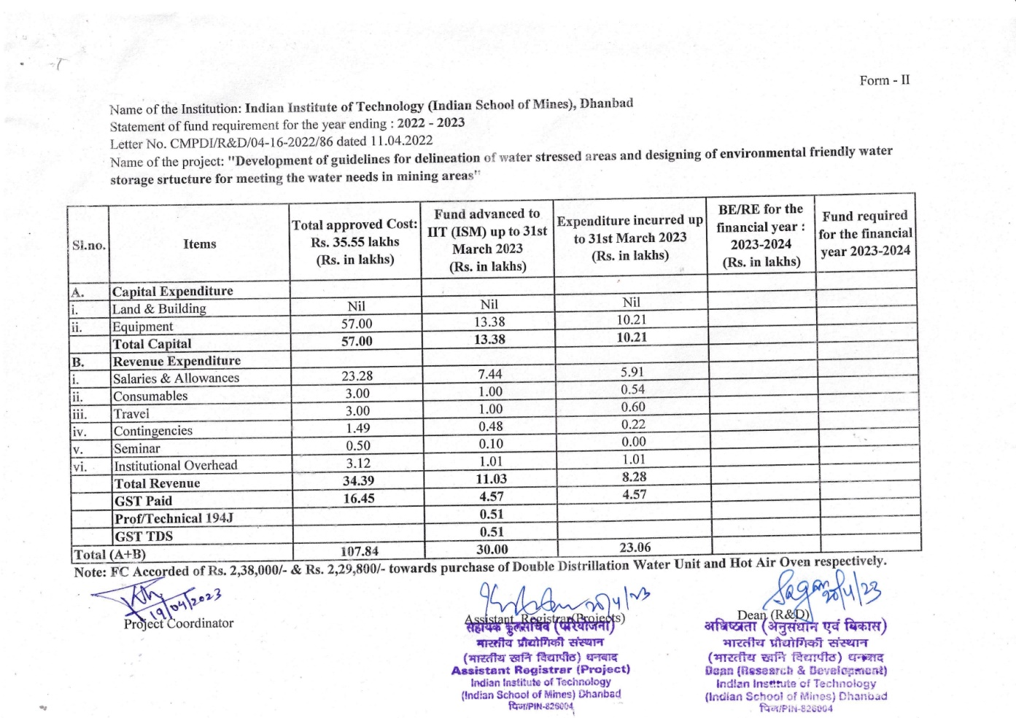7.3 FORM - II**

**7.4 FORM III**

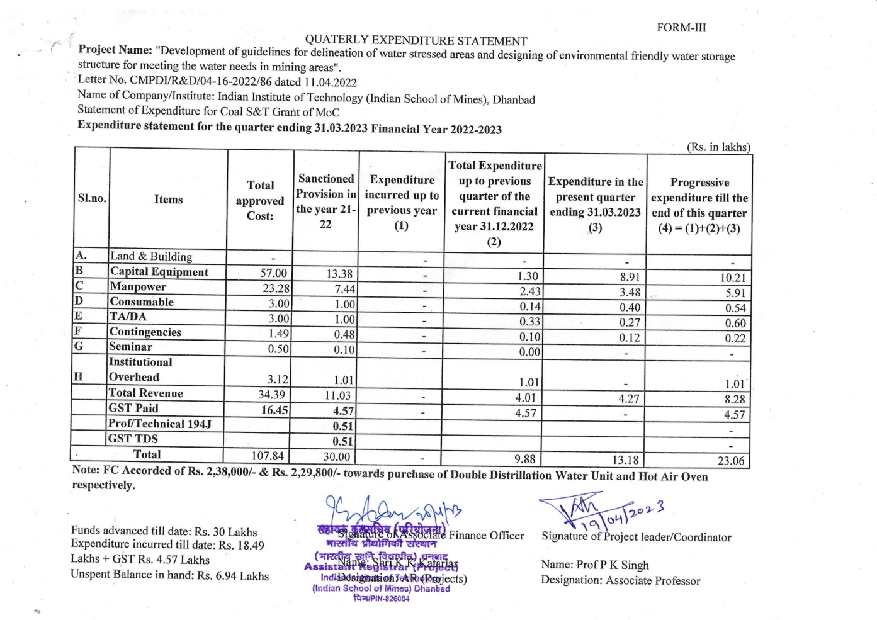

#### 7.5 FORM – IV

**FUNDS REQUIREMENTS FOR 3RD - YEAR**

#### Important request for release of 3rd year funds of Equipment’s Capital Expenditure in the 2nd year funds only, so that the Equipment can be purchased in time.